**ASP.NET MVC 5**

ASP.NET is a free web framework for building websites and web applications on .NET Framework using HTML, CSS, and JavaScript.

ASP.NET MVC 5 is a web framework based on Mode-View-Controller (MVC) architecture. Developers can build dynamic web applications using ASP.NET MVC framework that enables a clean separation of concerns, fast development, and TDD friendly.

This course is designed for beginners and professionals who want to learn ASP.NET MVC 5.

Prerequisites

Basic knowledge of .NET Framework 4.5, C#, and Visual Studio is required.

Table of Contents:

* ASP.NET MVC Architecture
* ASP.NET MVC Version History
* Create ASP.NET MVC Application
* ASP.NET MVC Folder Structure
* Routing in MVC
* Controllers in ASP.NET MVC
* Action method
* Action Selectors
* ActionVerbs: HttpGet, HttpPost, HttpPut
* Model in ASP.NET MVC
* Create a View in ASP.NET MVC
* Integrate Controller, View and Model
* Bind Query String to an Action Method Parameters in MVC
* Create Edit View in ASP.NET MVC
* Razor Syntax
* HTML Helpers
* Create a Textbox in ASP.NET MVC
* Create TextArea in ASP.NET MVC
* Create Checkbox in ASP.NET MVC
* Create Radio buttons in ASP.NET MVC
* Create DropdownList in ASP.NET MVC
* Create a Hidden Field in ASP.NET MVC
* Create Password field in ASP.NET MVC
* HtmlHelper - Display HTML String
* Create Label in ASP.NET MVC
* Create HTML Controls for Model Class Properties using EditorFor()
* Exception Handling in ASP.NET MVC
* Implement Data Validation in MVC
* ASP.NET MVC: ValidationMessageFor
* ASP.NET MVC: ValidationSummary
* What is Layout View in ASP.NET MVC
* Create a Layout View
* Create and Render Partial Views
* ASP.NET MVC - ViewBag
* ASP.NET MVC - TempData
* ASP.NET MVC- Filters
* ASP.NET MVC - Action Filters
* Bundling and Minification
* Combine Script Files using ScriptBundle in ASP.NET MVC
* StyleBundle - Combine CSS Files in ASP.NET MVC
* Area in ASP.NET MVC

# ASP.NET MVC Architecture

Here, you will learn an overview of MVC architecture.

The MVC architectural pattern has existed for a long time in software engineering. All most all the languages use MVC with slight variation, but conceptually it remains the same.

Let's understand the MVC architecture supported in ASP.NET.

MVC stands for Model, View, and Controller. MVC separates an application into three components - Model, View, and Controller.

**Model**: Model represents the shape of the data. A class in C# is used to describe a model. Model objects store data retrieved from the database.

**Model represents the data**.

**View**: View in MVC is a user interface. View display model data to the user and also enables them to modify them. View in ASP.NET MVC is HTML, CSS, and some special syntax (Razor syntax) that makes it easy to communicate with the model and the controller.

**View is the User Interface.**

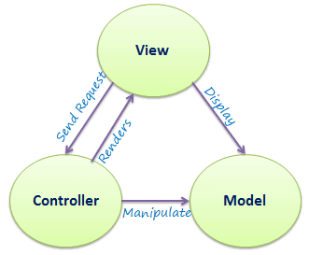**Controller**: The controller handles the user request. Typically, the user uses the view and raises an HTTP request, which will be handled by the controller. The controller processes the request and returns the appropriate view as a response.

**Controller is the request handler.**

The figure at right illustrates the interaction between Model, View, and Controller.

MVC Architecture

The following figure illustrates the flow of the user's request in ASP.NET MVC.

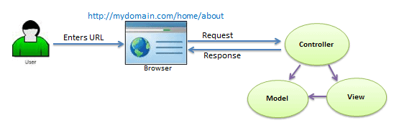

Request Flow in MVC Architecture

As per the above figure, when a user enters a URL in the browser, it goes to the webserver and routed to a controller. A controller executes related view and models for that request and create the response and sends it back to the browser.

 Points to Remember

1. MVC stands for Model, View and Controller.
2. Model represents the data
3. View is the User Interface.
4. Controller is the request handler.

# ASP.NET MVC Version History

Microsoft had introduced ASP.NET MVC in .NET 3.5, since then lots of new features have been added.

The following table list brief history of ASP.NET MVC.

| MVC Version | Visual Studio | .NET Framework | Released Date | Features |
| --- | --- | --- | --- | --- |
| MVC 1.0 | VS2008 | .NET 3.5 | 13-Mar-2009 | * MVC architecture with webform engine * Routing * HTML Helpers * Ajax Helpers * Auto binding |
| MVC 2.0 | VS 2008, | .NET 3.5/4.0 | 10-Mar-2010 | * Area * Asynchronous controller * Html helper methods with lambda expression * DataAnnotations attributes * Client side validation * Custom template * Scaffolding |
| MVC 3.0 | VS 2010 | .NET 4.0 | 13-Jan-2011 | * Unobtrusive javascript validation * Razor view engine * Global filters * Remote validation * Dependency resolver for IoC * ViewBag |
| MVC 4.0 | VS 2010 SP1, VS 2012 | .NET 4.0/4.5 | 15-Aug-2012 | * Mobile project template * Bundling and minification * Support for Windows Azure SDK |
| MVC 5.0 | VS 2013 | .NET 4.5 | 17-oct-2013 | * Authentication filters * Bootstrap support * New scaffolding items * ASP.NET Identity |
| MVC 5.2 | VS 2013 | .NET 4.5 | 28-Aug-2014 | * Attribute based routing * bug fixes and minor features update |

Let's create first simple MVC application in the next section.

# Create ASP.NET MVC Application

In this section, we will create a new MVC web application using Visual Studio and understand the basic building blocks of the ASP.NET MVC Application.

We are going to use ASP.NET MVC v5.2, and Visual Studio 2017 community edition, and .NET Framework 4.6 to create our first MVC application.

Download the latest version of Visual Studio from [visualstudio.microsoft.com/downloads](https://visualstudio.microsoft.com/downloads/).

Open Visual Studio 2017 and select **File menu** -> **New** -> **Project**, as shown below.

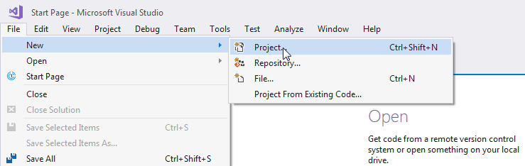Create a New Project in Visual Studio

From the **New Project** dialog as shown below, expand Visual C# node and select **Web** in the left pane, and then select **ASP.NET Web Application (.NET Framework)** in the middle pane. Enter the name of your project MyMVCApplication. (You can give an appropriate name for your application). Also, you can change the location of the MVC application by clicking on **Browse..** button. Finally, click **OK.**

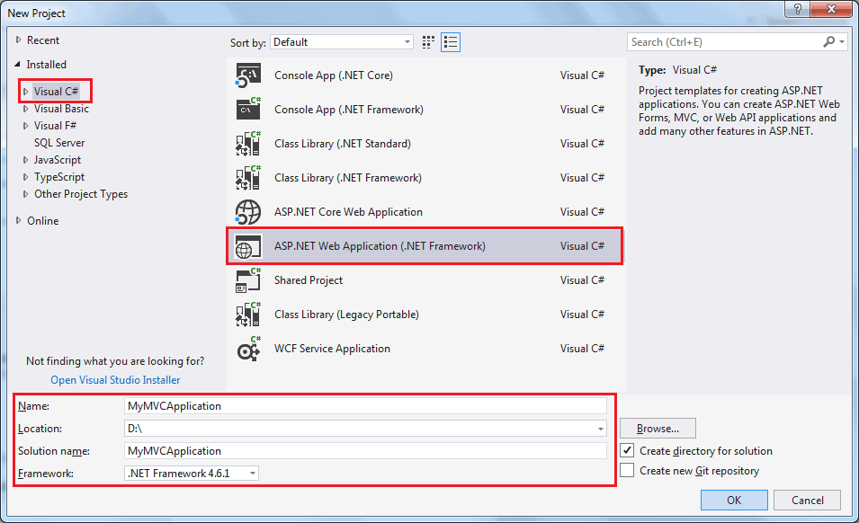

From the **New ASP.NET Web Application** dialog, select MVC (if not selected already) as shown below.

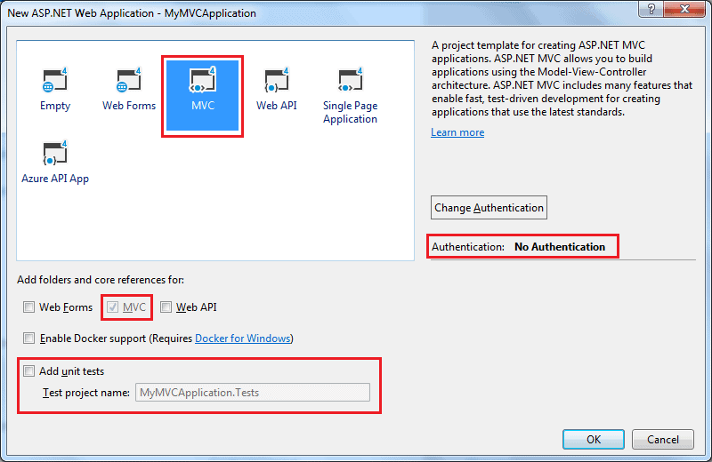

Select MVC Project Template

You can also change the authentication by clicking on **Change Authentication** button. You can select appropriate authentication mode for your application, as shown below.

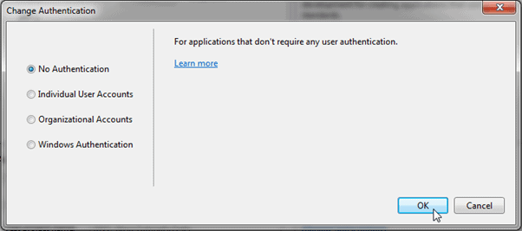Select Authentication Type

Here, we are keeping the default authentication for our application which is No Authentication. Click **OK** to continue.

Wait for some time till Visual Studio creates a simple MVC project using the default template, as shown below.

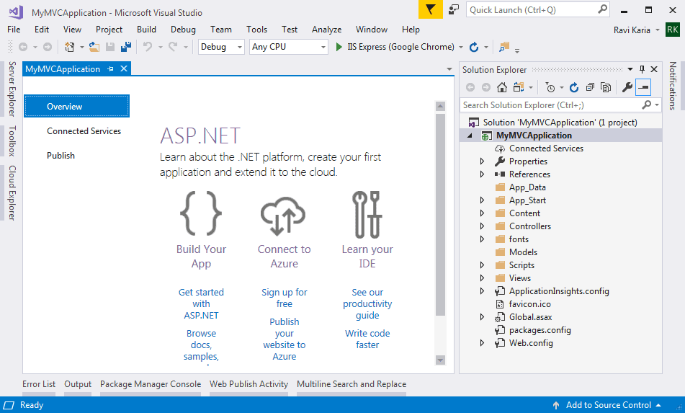

MVC Project in Visual Studio

Now, press F5 to run the project in debug mode or Ctrl + F5 to run the project without debugging. It will open the home page in the browser, as shown below.

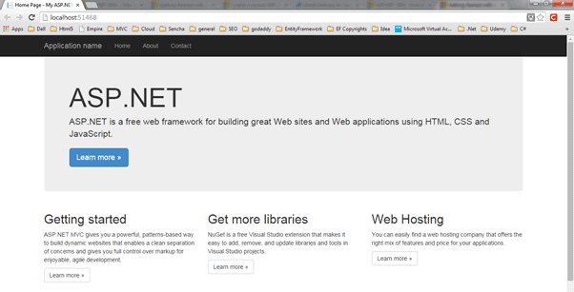

ASP.NET MVC Application

MVC 5 project includes JavaScript and CSS files of bootstrap 3.0 by default. So, you can create responsive web pages. This responsive UI will change its look and feel based on the screen size of the different devices. For example, the top menu bar will be changed in the mobile devices, as shown below.

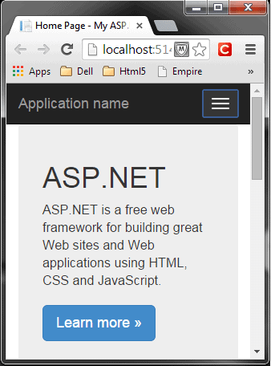 Responsive MVC Application

In this way, you can create your ASP.NET MVC 5 application using Visual Studio 2017.

Learn about ASP.NET MVC project's folder structure in the next section.

# ASP.NET MVC Folder Structure

Here, you will learn about the ASP.NET MVC project structure. Visual Studio creates the following folder structure of the ASP.NET MVC application by default.

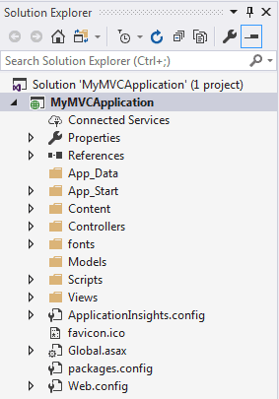 MVC Folder Structure

Let's see significance of each folder.

### **App\_Data**

The App\_Data folder can contain application data files like LocalDB, .mdf files, XML files, and other data related files. IIS will never serve files from App\_Data folder.

### **App\_Start**

The App\_Start folder can contain class files that will be executed when the application starts. Typically, these would be config files like AuthConfig.cs, BundleConfig.cs, FilterConfig.cs, RouteConfig.cs etc. MVC 5 includes BundleConfig.cs, FilterConfig.cs and RouteConfig.cs by default. We will see the significance of these files later.

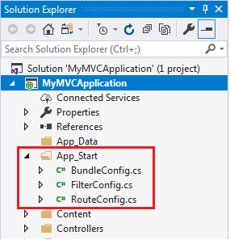 App\_Start Folder

### **Content**

The Content folder contains static files like CSS files, images, and icons files. MVC 5 application includes bootstrap.css, bootstrap.min.css, and Site.css by default.

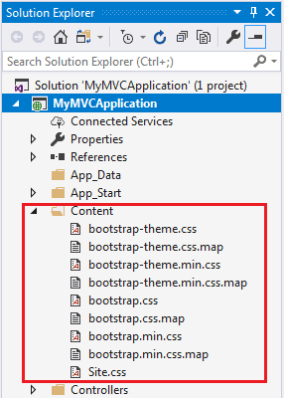 Content Folder

### **Controllers**

The Controllers folder contains class files for the controllers. A Controller handles users' request and returns a response. MVC requires the name of all controller files to end with "Controller". You will learn about the controller in the next section.

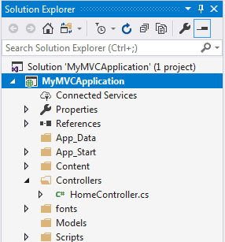 Controller Folder

### **fonts**

The Fonts folder contains custom font files for your application.

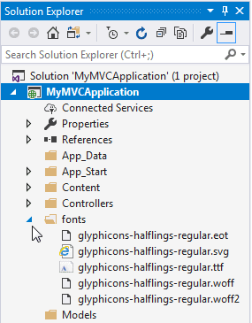 Fonts folder

### **Models**

The Models folder contains model class files. Typically, model class includes public properties, which will be used by the application to hold and manipulate application data.

### **Scripts**

The Scripts folder contains JavaScript or VBScript files for the application. MVC 5 includes JavaScript files for bootstrap, jQuery 1.10, and modernizer by default.

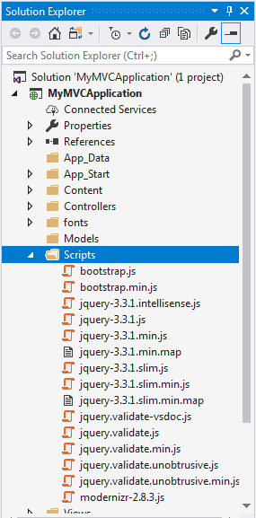 Scripts Folder

### **Views**

The Views folder contains HTML files for the application. Typically view file is a .cshtml file where you write HTML and C# or VB.NET code.

The Views folder includes a separate folder for each controller. For example, all the .cshtml files, which will be rendered by HomeController will be in View > Home folder.

The Shared folder under the View folder contains all the views shared among different controllers e.g., layout files.

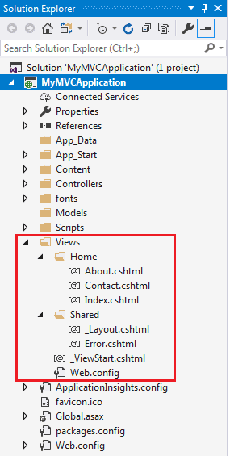 View Folder

Additionally, MVC project also includes the following configuration files:

### **Global.asax**

Global.asax file allows you to write code that runs in response to application-level events, such as Application\_BeginRequest, application\_start, application\_error, session\_start, session\_end, etc.

### **Packages.config**

Packages.config file is managed by NuGet to track what packages and versions you have installed in the application.

### **Web.config**

Web.config file contains application-level configurations.

Learn how the ASP.NET MVC framework handles requests using routing in the next section.

# Routing in MVC

In the ASP.NET Web Forms application, every URL must match with a specific .aspx file. For example, a URL http://domain/studentsinfo.aspx must match with the file studentsinfo.aspx that contains code and markup for rendering a response to the browser.

Routing is not specific to the MVC framework. It can be used with ASP.NET Webform application or MVC application.

ASP.NET introduced Routing to eliminate the needs of mapping each URL with a physical file. Routing enables us to define a URL pattern that maps to the request handler. This request handler can be a file or class. In ASP.NET Webform application, request handler is .aspx file, and in MVC, it is the Controller class and Action method. For example, http://domain/students can be mapped to http://domain/studentsinfo.aspx in ASP.NET Webforms, and the same URL can be mapped to Student Controller and Index action method in MVC.

Route

Route defines the URL pattern and handler information. All the configured routes of an application stored in RouteTable and will be used by the Routing engine to determine appropriate handler class or file for an incoming request.

The following figure illustrates the Routing process.

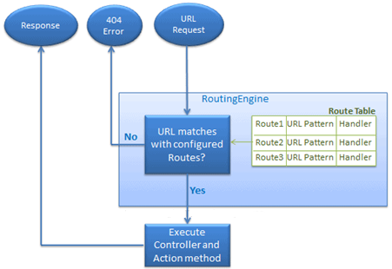

Routing in MVC

Configure a Route

Every MVC application must configure (register) at least one route configured by the MVC framework by default. You can register a route in RouteConfig class, which is in RouteConfig.cs under App\_Start folder. The following figure illustrates how to configure a route in the RouteConfig class .

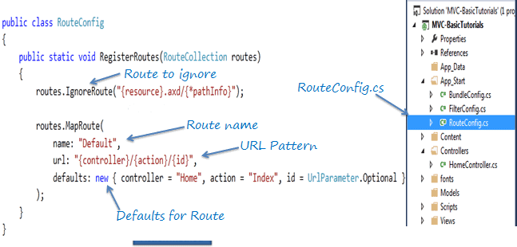Configure Routes in MVC

As you can see in the above figure, the route is configured using the MapRoute() extension method of RouteCollection, where name is "Default", url pattern is "{controller}/{action}/{id}" and defaults parameter for controller, action method and id parameter. Defaults specify which controller, action method, or value of id parameter should be used if they do not exist in the incoming request URL.

In the same way, you can configure other routes using the MapRoute() method of the RouteCollection class. This RouteCollection is actually a property of the [RouteTable](https://msdn.microsoft.com/en-us/library/system.web.routing.routetable(v=vs.110).aspx" \t "_blank) class.

URL Pattern

The URL pattern is considered only after the domain name part in the URL. For example, the URL pattern *"{controller}/{action}/{id}"* would look like localhost:1234/{controller}/{action}/{id}. Anything after "localhost:1234/" would be considered as a controller name. The same way, anything after the controller name would be considered as action name and then the value of id parameter.

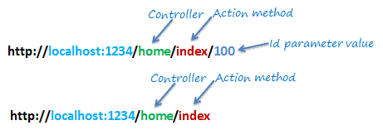

Routing in MVC

If the URL doesn't contain anything after the domain name, then the default controller and action method will handle the request. For example, http://localhost:1234 would be handled by the HomeController and the Index() method as configured in the default parameter.

The following table shows which Controller, Action method, and Id parameter would handle different URLs considering the above default route.

| URL | Controller | Action | Id |
| --- | --- | --- | --- |
| http://localhost/home | HomeController | Index | null |
| http://localhost/home/index/123 | HomeController | Index | 123 |
| http://localhost/home/about | HomeController | About | null |
| http://localhost/home/contact | HomeController | Contact | null |
| http://localhost/student | StudentController | Index | null |
| http://localhost/student/edit/123 | StudentController | Edit | 123 |

Multiple Routes

You can also configure a custom route using the MapRoute extension method. You need to provide at least two parameters in MapRoute, route name, and URL pattern. The Defaults parameter is optional.

You can register multiple custom routes with different names. Consider the following example where we register "Student" route.

Example: Custom Routes

**public class** RouteConfig

{

**public static void** RegisterRoutes(RouteCollection routes)

{

routes.IgnoreRoute("{resource}.axd/{\*pathInfo}");

routes.MapRoute(

**name**: "Student",

**url**: "students/{id}",

**defaults**: **new** { controller = "Student", action = "Index"}

);

routes.MapRoute(

**name**: "Default",

**url**: "{controller}/{action}/{id}",

**defaults**: **new** { controller = "Home", action = "Index",

id = UrlParameter.Optional }

);

}

}

As shown in the above code, the URL pattern for the Student route is *students/{id}*, which specifies that any URL that starts with domainName/students, must be handled by the StudentController. Notice that we haven't specified {action} in the URL pattern because we want every URL that starts with students should always use the Index() action of the StudentController class. We have specified the default controller and action to handle any URL request, which starts from domainname/students.

MVC framework evaluates each route in sequence. It starts with the first configured route, and if incoming URL doesn't satisfy the URL pattern of the route, then it will evaluate the second route and so on. In the above example, routing engine will evaluate the Student route first and if incoming URL doesn't start with /students then only it will consider the second route which is the default route.

The following table shows how different URLs will be mapped to the Student route:

| URL | Controller | Action | Id |
| --- | --- | --- | --- |
| http://localhost/student/123 | StudentController | Index | 123 |
| http://localhost/student/index/123 | StudentController | Index | 123 |
| http://localhost/student?Id=123 | StudentController | Index | 123 |

Route Constraints

You can also apply restrictions on the value of the parameter by configuring route constraints. For example, the following route applies a limitation on the id parameter that the id's value must be numeric.

Example: Route Constraints

routes.MapRoute(

**name**: "Student",

**url**: "student/{id}/{name}/{standardId}",

**defaults**: **new** { controller = "Student", action = "Index",

id = UrlParameter.Optional,

name = UrlParameter.Optional,

standardId = UrlParameter.Optional },

**constraints**: **new** { id = @"\d+" }

);

So, if you give non-numeric value for id parameter, then that request will be handled by another route or, if there are no matching routes, then "The resource could not be found" error will be thrown.

Register Routes

Now, after configuring all the routes in the RouteConfig class, you need to register it in the Application\_Start() event in the Global.asax so that it includes all your routes into the RouteTable.

Example: Route Registration

**public class** MvcApplication : System.Web.HttpApplication

{

**protected void** Application\_Start()

{

RouteConfig.RegisterRoutes(RouteTable.Routes);

}

}

The following figure illustrate Route registration process.

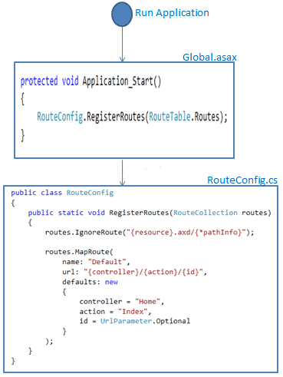

Register Route

Thus, routing plays important role in MVC framework.

 Points to Remember :

1. Routing plays important role in the MVC framework. Routing maps URL to physical file or class (controller class in MVC).
2. Route contains URL pattern and handler information. URL pattern starts after the domain name.
3. Routes can be configured in RouteConfig class. Multiple custom routes can also be configured.
4. Route constraints apply restrictions on the value of parameters.
5. Route must be registered in Application\_Start event in Global.ascx.cs file.

# Controllers in ASP.NET MVC

In this section, you will learn about the Controller in ASP.NET MVC.

The Controller in MVC architecture handles any incoming URL request. The Controller is a class, derived from the base class System.Web.Mvc.Controller. Controller class contains public methods called **Action** methods. Controller and its action method handles incoming browser requests, retrieves necessary model data and returns appropriate responses.

In ASP.NET MVC, every controller class name must end with a word "Controller". For example, the home page controller name must be HomeController, and for the student page, it must be the StudentController. Also, every controller class must be located in the Controller folder of the MVC folder structure.

## **Adding a New Controller**

Now, let's add a new empty controller in our MVC application in Visual Studio.

MVC will throw "The resource cannot be found" error when you do not append "Controller" to the controller class name.

In the previous section, we learned how to create our first MVC application, which created a default HomeController. Here, we will create new StudentController class.

In the Visual Studio, right click on the Controller folder -> select **Add** -> click on **Controller..**

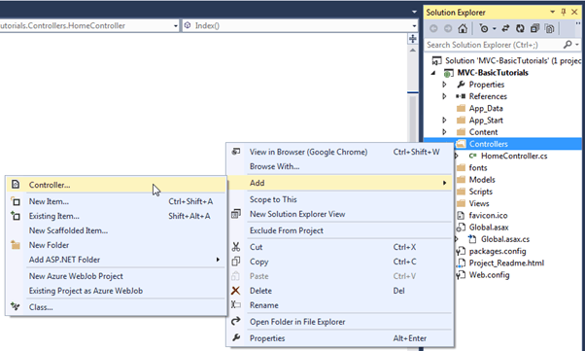 Add New Controller

This opens Add Scaffold dialog, as shown below.

 Note:

Scaffolding is an automatic code generation framework for ASP.NET web applications. Scaffolding reduces the time taken to develop a controller, view, etc. in the MVC framework. You can develop a customized scaffolding template using T4 templates as per your architecture and coding standards.

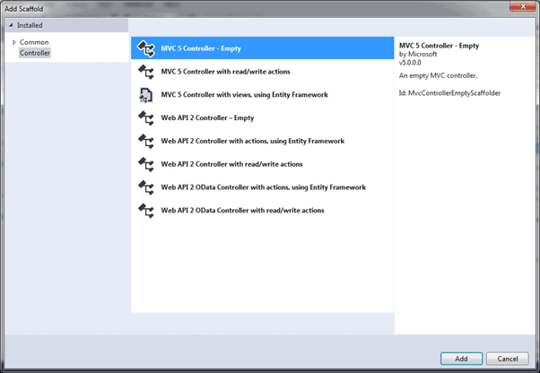

Adding Controller

Add Scaffold dialog contains different templates to create a new controller. We will learn about other templates later. For now, select "MVC 5 Controller - Empty" and click Add. It will open the Add Controller dialog, as shown below

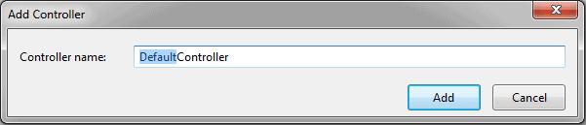 Adding Controller

In the **Add Controller** dialog, enter the name of the controller. Remember, the controller name must end with Controller. Write StudentController and click **Add**.

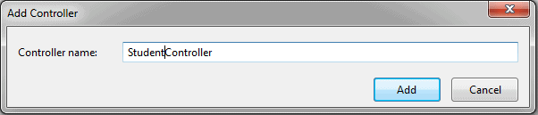 Adding Controller

This will create the StudentController class with the Index() method in StudentController.cs file under the Controllers folder, as shown below.

Example: Controller

**using** System;

**using** System.Collections.Generic;

**using** System.Linq;

**using** System.Web;

**using** System.Web.Mvc;

**namespace** MVC\_BasicTutorials.Controllers

{

**public class** StudentController : Controller

{

// GET: Student

**public** ActionResult Index()

{

**return** View();

}

}

}

As you can see above, the StudentController class is derived from the Controller class. Every controller in MVC must be derived from this abstract Controller class. This base Controller class contains helper methods that can be used for various purposes.

Now, we will return a dummy string from the Index action method of above the StudentController. Changing the return type of Index method from ActionResult to string and returning dummy string is shown below. You will learn about the ActionResult in the next section.

Example: Controller

**using** System;

**using** System.Collections.Generic;

**using** System.Linq;

**using** System.Web;

**using** System.Web.Mvc;

**namespace** MVC\_BasicTutorials.Controllers

{

**public class** StudentController : Controller

{

// GET: Student

**public string** Index()

{

**return** "This is Index action method of StudentController";

}

}

}

We have already seen in the routing section that the URL request http://localhost/student or http://localhost/student/index is handled by the Index() method of the StudentController class, as shown above. So let's invoke it from the browser and you will see the following page in the browser.

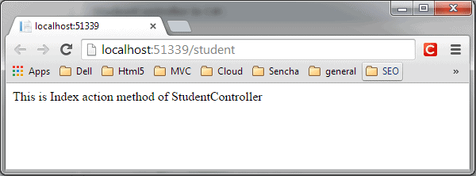 Controller

 Points to Remember :

1. The Controller handles incoming URL requests. MVC routing sends requests to the appropriate controller and action method based on URL and configured Routes.
2. All the public methods in the Controller class are called Action methods.
3. The Controller class must be derived from System.Web.Mvc.Controller class.
4. The Controller class name must end with "Controller".
5. A new controller can be created using different scaffolding templates. You can create a custom scaffolding template also.

# Action method

In this section, you will learn about the action method of the controller class.

All the public methods of the Controller class are called Action methods. They are like any other normal methods with the following restrictions:

1. Action method must be public. It cannot be private or protected
2. Action method cannot be overloaded
3. Action method cannot be a static method.

The following illustrates the Index() action method in the StudentController class.

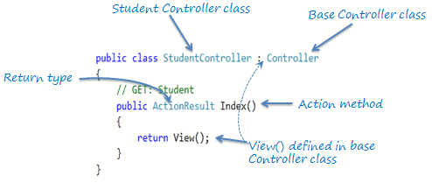 Action Method

As you can see in the above figure, the Index() method is public, and it returns the ActionResult using the View() method. The View() method is defined in the Controller base class, which returns the appropriate ActionResult.

## **Default Action Method**

Every controller can have a default action method as per the configured route in the RouteConfig class. By default, the Index() method is a default action method for any controller, as per configured default root, as shown below.

Default Route

routes.MapRoute(

**name**: "Default",

**url**: "{controller}/{action}/{id}/{name}",

**defaults**: **new** { controller = "Home",

action = "Index",

id = UrlParameter.Optional

});

However, you can change the default action name as per your requirement in the RouteConfig class.

## **ActionResult**

MVC framework includes various Result classes, which can be returned from an action method. The result classes represent different types of responses, such as HTML, file, string, JSON, javascript, etc. The following table lists all the result classes available in ASP.NET MVC.

| Result Class | Description |
| --- | --- |
| ViewResult | Represents HTML and markup. |
| EmptyResult | Represents No response. |
| ContentResult | Represents string literal. |
| FileContentResult/ FilePathResult/ FileStreamResult | Represents the content of a file. |
| JavaScriptResult | Represent a JavaScript script. |
| JsonResult | Represent JSON that can be used in AJAX. |
| RedirectResult | Represents a redirection to a new URL. |
| RedirectToRouteResult | Represent another action of same or other controller. |
| PartialViewResult | Returns HTML from Partial view. |
| HttpUnauthorizedResult | Returns HTTP 403 status. |

The ActionResult class is a base class of all the above result classes, so it can be the return type of action method that returns any result listed above. However, you can specify the appropriate result class as a return type of action method.

The Index() method of the StudentController in the above figure uses the View() method to return a ViewResult (which is derived from the ActionResult class). The base Controller class includes the View() method along with other methods that return a particular type of result, as shown in the below table.

| Result Class | Description | Base Controller Method |
| --- | --- | --- |
| ViewResult | Represents HTML and markup. | View() |
| EmptyResult | Represents No response. |  |
| ContentResult | Represents string literal. | Content() |
| FileContentResult, FilePathResult, FileStreamResult | Represents the content of a file. | File() |
| JavaScriptResult | Represents a JavaScript script. | JavaScript() |
| JsonResult | Represents JSON that can be used in AJAX. | Json() |
| RedirectResult | Represents a redirection to a new URL. | Redirect() |
| RedirectToRouteResult | Represents redirection to another route. | RedirectToRoute() |
| PartialViewResult | Represents the partial view result. | PartialView() |
| HttpUnauthorizedResult | Represents HTTP 403 response. |  |

As you can see in the above table, the View() method returns the ViewResult, the Content() method returns a string, the File() method returns the content of a file, and so on. Use different methods mentioned in the above table to return a different type of result from an action method.

## **Action Method Parameters**

Every action method can have input parameters as normal methods. It can be primitive data type or complex type parameters, as shown below.

Example: Action Method Parameters

**public** ActionResult Edit(Student std)

{

// update student to the database

**return** RedirectToAction("Index");

}

[HttpDelete]

**public** ActionResult Delete(**int** id)

{

// delete student from the database whose id matches with specified id

**return** RedirectToAction("Index");

}

Please note that action method parameter can be Nullable Type.

By default, the values for action method parameters are retrieved from the request's data collection. The data collection includes name/values pairs for form data or query string values or cookie values. Model binding in ASP.NET MVC automatically maps the URL query string or form data collection to the action method parameters if both names match.

 Points to Remember:

1. All the public methods in the Controller class are called Action methods.
2. The Action method has the following restrictions.  
       - Action method must be public. It cannot be private or protected.  
       - Action method cannot be overloaded.  
       - Action method cannot be a static method.
3. ActionResult is a base class of all the result type which returns from Action method.
4. The base Controller class contains methods that returns appropriate result type e.g. View(), Content(), File(), JavaScript() etc.
5. The Action method can include Nullable type parameters.

# Action Selectors

Action selector is the attribute that can be applied to the action methods. It helps the routing engine to select the correct action method to handle a particular request. MVC 5 includes the following action selector attributes:

1. ActionName
2. NonAction
3. ActionVerbs

## **ActionName**

The ActionName attribute allows us to specify a different action name than the method name, as shown below.

Example: Specify a different action name

**public class** StudentController : Controller

{

**public** StudentController()

{

}

[ActionName("Find")]

**public** ActionResult GetById(**int** id)

{

// get student from the database

**return** View();

}

}

In the above example, we have applied ActioName("find") attribute to the GetById() action method. So now, the action method name is Find instead of the GetById. So now, it will be invoked on http://localhost/student/find/1 request instead of http://localhost/student/getbyid/1 request.

## **NonAction**

Use the NonAction attribute when you want public method in a controller but do not want to treat it as an action method.

In the following example, the Index() method is an action method, but the GetStudent() is not an action method.

Example: NonAction

**public class** StudentController : Controller

{

**public string** Index()

{

**return** "This is Index action method of StudentController";

}

[NonAction]

**public** Student GetStudent(**int** id)

{

**return** studentList.Where(s => s.StudentId == id).FirstOrDefault();

}

}

# ActionVerbs: HttpGet, HttpPost, HttpPut

The ActionVerbs selector is to handle different type of Http requests. The MVC framework includes HttpGet, HttpPost, HttpPut, HttpDelete, HttpOptions, and HttpPatch action verbs. You can apply one or more action verbs to an action method to handle different HTTP requests. If you don't apply any action verbs to an action method, then it will handle HttpGet request by default.

The following table lists the usage of HTTP methods:

| Http method | Usage |
| --- | --- |
| GET | To retrieve the information from the server. Parameters will be appended in the query string. |
| POST | To create a new resource. |
| PUT | To update an existing resource. |
| HEAD | Identical to GET except that server do not return the message body. |
| OPTIONS | It represents a request for information about the communication options supported by the web server. |
| DELETE | To delete an existing resource. |
| PATCH | To full or partial update the resource. |

Visit [W3.org](https://www.w3.org/Protocols/rfc2616/rfc2616-sec9.html) for more information on Http Methods.

The following example shows how to handle different types of HTTP requests in the Controller using ActionVerbs:

Example: Handle HTTP Requests in the Controller

**public class** StudentController : Controller

{

**public** ActionResult Index() // handles GET requests by default

{

**return** View();

}

[HttpPost]

**public** ActionResult PostAction() // handles POST requests by default

{

**return** View("Index");

}

[HttpPut]

**public** ActionResult PutAction() // handles PUT requests by default

{

**return** View("Index");

}

[HttpDelete]

**public** ActionResult DeleteAction() // handles DELETE requests by default

{

**return** View("Index");

}

[HttpHead]

**public** ActionResult HeadAction() // handles HEAD requests by default

{

**return** View("Index");

}

[HttpOptions]

**public** ActionResult OptionsAction() // handles OPTION requests by default

{

**return** View("Index");

}

[HttpPatch]

**public** ActionResult PatchAction() // handles PATCH requests by default

{

**return** View("Index");

}

}

You can also apply multiple action verbs using the AcceptVerbs attribute, as shown below.

Example: AcceptVerbs

[AcceptVerbs(HttpVerbs.Post | HttpVerbs.Get)]

**public** ActionResult GetAndPostAction()

{

**return** RedirectToAction("Index");

}

# Model in ASP.NET MVC

In this section, you will learn about the model class in ASP.NET MVC framework.

The model classes represent domain-specific data and business logic in the MVC application. It represents the shape of the data as public properties and business logic as methods.

In the ASP.NET MVC Application, all the Model classes must be created in the Model folder.

## **Adding a Model Class**

Let's create the model class that should have the required properties for the Student entity.

In the MVC application in Visual Studio, and right-click on the Model folder, select **Add** -> and click on **Class..**. It will open the **Add New Item** dialog box.

In the Add New Item dialog box, enter the class name Student and click **Add**.

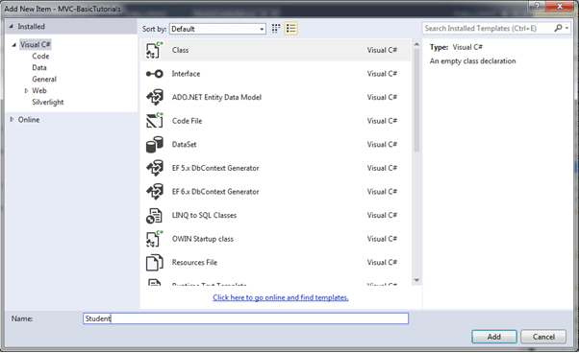

Create Model Class

This will add a new Student class in model folder. We want this model class to store id, name, and age of the students. So, we will have to add public properties for Id, Name, and Age, as shown below.

Example: Model class

**public class** Student

{

**public int** StudentId { get; set; }

**public string** StudentName { get; set; }

**public int** Age { get; set; }

}

The model class can be used in the view to populate the data, as well as sending data to the controller.

Let's create a view and use this model in the next chapter.

# Create a View in ASP.NET MVC

In this section, you will learn how to create a view and use the model class in it in the ASP.NET MVC application.

A view is used to display data using the model class object. The **Views** folder contains all the view files in the ASP.NET MVC application.

A controller can have one or more action methods, and each action method can return a different view. In short, a controller can render one or more views. So, for easy maintenance, the MVC framework requires a separate sub-folder for each controller with the same name as a controller, under the **Views** folder.

For example, all the views rendered from the HomeController will resides in the **Views** > **Home** folder. In the same way, views for StudentController will resides in **Views** > **Student** folder, as shown below.

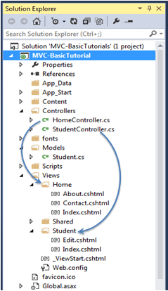 View folders for Controllers

 Note:

The **Shared** folder contains views, layout views, and partial views, which will be shared among multiple controllers.

## **Razor View Engine**

Microsoft introduced the razor view engine to compile a view with a mix of HTML tags and server-side code. The special syntax for razor view maximizes the speed of writing code by minimizing the number of characters and keystrokes required when writing a view.

The razor view uses @ character to include the server-side code instead of the traditional <% %> of ASP. You can use C# or Visual Basic syntax to write server-side code inside the razor view.

ASP.NET MVC supports the following types of razor view files:

| File extension | Description |
| --- | --- |
| .cshtml | C# Razor view. Supports C# code with html tags. |
| .vbhtml | Visual Basic Razor view. Supports Visual Basic code with html tags. |
| .aspx | ASP.NET web form |
| .ascx | ASP.NET web control |

## **Creating a View**

You can create a view for an action method directly from it by right clicking inside an action method and select **Add View..**.

The following creates a view from the Index() action method of the StudentContoller, as shown below.

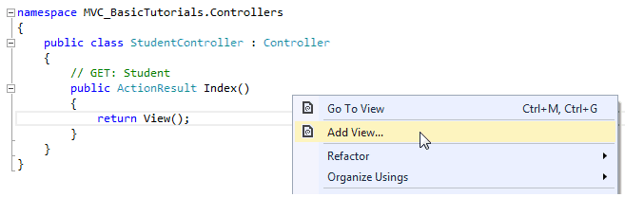Create a View from Action Method

This will open the **Add View** dialogue box, shown below. It's good practice to keep the view name the same as the action method name so that you don't have to explicitly specify the view name in the action method while returning the view.

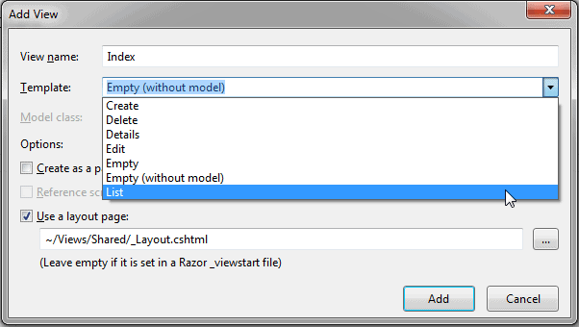Add a View

Select the scaffolding template. Template dropdown will show default templates available for Create, Delete, Details, Edit, List, or Empty view. Select "List" template because we want to show the list of students in the view.

Now, select Student from the model class dropdown. The model class dropdown automatically displays the name of all the classes in the Model folder. We have already created the Student model class in the previous section, so it would be included in the dropdown.

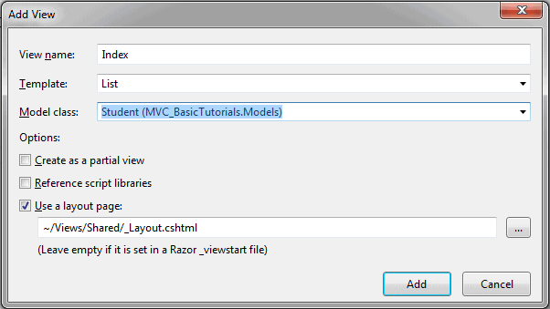 Add a View

Check "Use a layout page" checkbox and select the default \_Layout.cshtml page for this view and then click **Add** button.

This will create the Index view under **View** -> **Student** folder, as shown below:

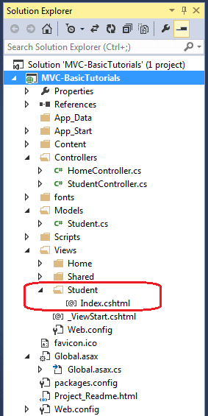 View

The following code snippet shows an Index.cshtml created above.

Views\Student\Index.cshtml:

@model IEnumerable<MVC\_BasicTutorials.Models.Student>

@{

ViewBag.Title = "Index";

Layout = "~/Views/Shared/\_Layout.cshtml";

}

**<h2>**Index**</h2>**

**<p>**

@Html.ActionLink("Create New", "Create")

**</p>**

**<table** **class**="table"**>**

**<tr>**

**<th>**

@Html.DisplayNameFor(model => model.StudentName)

**</th>**

**<th>**

@Html.DisplayNameFor(model => model.Age)

**</th>**

**<th></th>**

**</tr>**

@**foreach** (**var** item **in** Model) {

**<tr>**

**<td>**

@Html.DisplayFor(modelItem => item.StudentName)

**</td>**

**<td>**

@Html.DisplayFor(modelItem => item.Age)

**</td>**

**<td>**

@Html.ActionLink("Edit", "Edit", **new** { id=item.StudentId }) |

@Html.ActionLink("Details", "Details",

**new** { id=item.StudentId }) |

@Html.ActionLink("Delete", "Delete", **new** { id = item.StudentId })

**</td>**

**</tr>**

}

**</table>**

As you can see in the above Index view, it contains both HTML and razor codes. Inline razor expression starts with @ symbol. @Html is a helper class to generate HTML controls. You will learn razor syntax and HTML helpers in the coming sections.

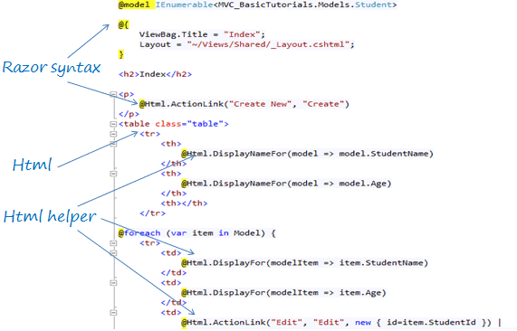 Index.cshtml

The above Index view would look as below when we run the application.

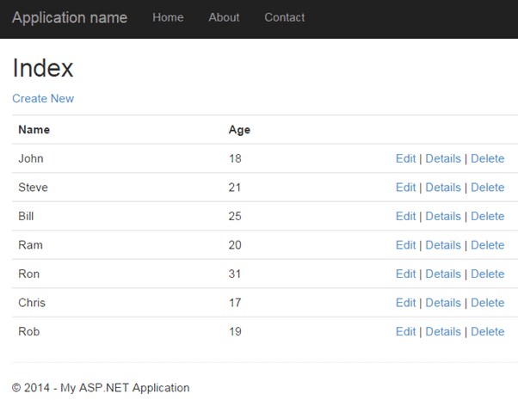 Index View

 Note:

Every view in the ASP.NET MVC is derived from WebViewPage class included in System.Web.Mvc namespace.

We need to pass a model object to a view in order to display the data on the view. Learn how to integrate a model, view, and controller in the next chapter.

# Integrate Controller, View and Model

We have already created a Controller, a model and a view in the previous sections. Here, we will integrate them to run the application and see the result.

The following code snippet shows the StudentController, the Student model, and the Index.cshtml view created in the previous sections.

Example: StudentController

**public class** StudentController : Controller

{

// GET: Student

**public** ActionResult Index()

{

**return** View();

}

}

Example: Student Model class

**public class** Student

{

**public int** StudentId { get; set; }

**public string** StudentName { get; set; }

**public int** Age { get; set; }

}

Example: Index.cshtml View

@model IEnumerable<MVC\_BasicTutorials.Models.Student>

@{

ViewBag.Title = "Index";

Layout = "~/Views/Shared/\_Layout.cshtml";

}

**<h2>**Index**</h2>**

**<p>**

@Html.ActionLink("Create New", "Create")

**</p>**

**<table** **class**="table"**>**

**<tr>**

**<th>**

@Html.DisplayNameFor(model => model.StudentName)

**</th>**

**<th>**

@Html.DisplayNameFor(model => model.Age)

**</th>**

**<th></th>**

**</tr>**

@**foreach** (**var** item **in** Model) {

**<tr>**

**<td>**

@Html.DisplayFor(modelItem => item.StudentName)

**</td>**

**<td>**

@Html.DisplayFor(modelItem => item.Age)

**</td>**

**<td>**

@Html.ActionLink("Edit", "Edit", **new** { id=item.StudentId }) |

@Html.ActionLink("Details", "Details",

**new** { id=item.StudentId }) |

@Html.ActionLink("Delete", "Delete", **new** { id = item.StudentId })

**</td>**

**</tr>**

}

**</table>**

Now, to run it successfully, we need to pass a model object from an action method to a view. As you can see in the above Index.cshtml, it uses IEnumerable<Student> as a model type. So we need to pass it from the Index() action method of the StudentController class, as shown below.

Example: Passing Model from Controller

**public class** StudentController : Controller

{

**static** IList<Student> studentList =

**new** List<Student>{

**new** Student() { StudentId = 1, StudentName = "John", Age = 18 } ,

**new** Student() { StudentId = 2, StudentName = "Steve", Age = 21 } ,

**new** Student() { StudentId = 3, StudentName = "Bill", Age = 25 } ,

**new** Student() { StudentId = 4, StudentName = "Ram" , Age = 20 } ,

**new** Student() { StudentId = 5, StudentName = "Ron" , Age = 31 } ,

**new** Student() { StudentId = 4, StudentName = "Chris" , Age = 17 } ,

**new** Student() { StudentId = 4, StudentName = "Rob" , Age = 19 }

};

// GET: Student

**public** ActionResult Index()

{

//fetch students from the DB using Entity Framework here

**return** View(studentList);

}

}

As you can see in the above code, we have created a list of student objects for an example purpose (in real-life application, you can fetch it from the database). We then pass this list object as a parameter in the View() method. The View() method is defined in the base Controller class, which automatically binds a model object to a view.

Now, you can run the MVC project by pressing F5 and navigate to http://localhost/Student. You will see the following view in the browser.



# Bind Query String to an Action Method Parameters in MVC

Here, you will learn about to bind a model object to an action method parameter in the ASP.NET MVC application.

The model binding refers to converting the HTTP request data (from the query string or form collection) to an action method parameter. These parameters can be of primitive type or complex type.

## **Binding to Primitive Type**

The HTTP GET request embeds data into a query string. MVC framework automatically converts a query string to the action method parameters provided their names are matching. For example, the query string id in the following GET request would automatically be mapped to the Edit() action method's id parameter.

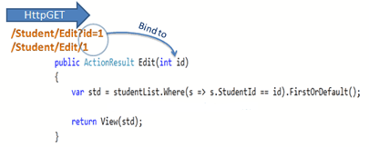

Model Binding

This binding is case insensitive. So "id" parameter can be "ID" or "Id".

You can also have multiple parameters in the action method with different data types. Query string values will be converted into parameters based on the matching names.

For example, the query string parameters of an HTTP request http://localhost/Student/Edit?id=1&name=John would map to id and name parameters of the following Edit() action method.

Example: Convert QueryString to Action Method Parameters

**public** ActionResult Edit(**int** id, **string** name)

{

// do something here

**return** View();

}

## **Binding to Complex Type**

Model binding also works on complex types. It will automatically convert the input fields data on the view to the properties of a complex type parameter of an action method in HttpPost request if the properties' names match with the fields on the view.

Example: Model classes in C#

**public class** Student

{

**public int** StudentId { get; set; }

**public string** StudentName { get; set; }

**public int** Age { get; set; }

**public** Standard standard { get; set; }

}

**public class** Standard

{

**public int** StandardId { get; set; }

**public string** StandardName { get; set; }

}

Now, you can create an action method which includes the Student type parameter. In the following example, Edit action method (HttpPost) includes Student type parameter.

Example: Action Method with Class Type Parameter

[HttpPost]

**public** ActionResult Edit(Student std)

{

**var** id = std.StudentId;

**var** name = std.StudentName;

**var** age = std.Age;

**var** standardName = std.standard.StandardName;

//update database here..

**return** RedirectToAction("Index");

}

Thus, the MVC framework will automatically map Form collection values to the Student type parameter when the form submits an HTTP POST request to the Edit() action method, as shown below.

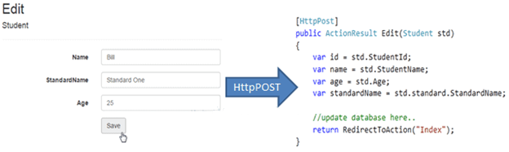Model Binding to Complex Type

So thus, it automatically binds form fields to the complex type parameter of action method.

### **FormCollection**

You can also include the FormCollection type parameter in the action method instead of a complex type to retrieve all the values from view form fields, as shown below.

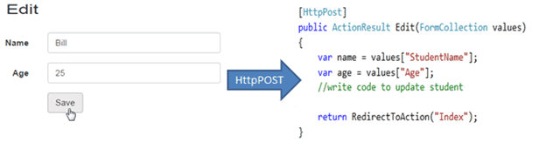Model Binding to FormCollection

## **Bind Attribute**

ASP.NET MVC framework also enables you to specify which properties of a model class you want to bind. The [Bind] attribute will let you specify the exact properties of a model should include or exclude in binding.

In the following example, the Edit() action method will only bind StudentId and StudentName properties of the Student model class.

Example: Binding Parameters

[HttpPost]

**public** ActionResult Edit([Bind(Include = "StudentId, StudentName")] Student std)

{

**var** name = std.StudentName;

//write code to update student

**return** RedirectToAction("Index");

}

You can also exclude the properties, as shown below.

Example: Exclude Properties in Binding

[HttpPost]

**public** ActionResult Edit([Bind(Exclude = "Age")] Student std)

{

**var** name = std.StudentName;

//write code to update student

**return** RedirectToAction("Index");

}

The Bind attribute will improve the performance by only bind properties that you needed.

## **Model Binding Process**

As you have seen, that the ASP.NET MVC framework automatically converts request values into a primitive or complex type object. Model binding is a two-step process. First, it collects values from the incoming HTTP request, and second, it populates primitive type or a complex type with these values.

Value providers are responsible for collecting values from requests, and Model Binders are responsible for populating values.

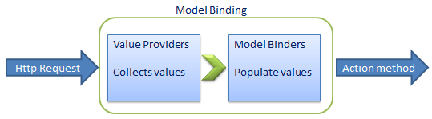

Model Binding in ASP.NET MVC

Default value provider collection evaluates values from the following sources:

1. Previously bound action parameters, when the action is a child action
2. Form fields (Request.Form)
3. The property values in the JSON Request body (Request.InputStream), but only when the request is an AJAX request
4. Route data (RouteData.Values)
5. Querystring parameters (Request.QueryString)
6. Posted files (Request.Files)

MVC includes DefaultModelBinder class which effectively binds most of the model types.

# Create Edit View in ASP.NET MVC

We created the list view in the Integrate Model, View, Controller chapter. Here, you will learn how to create the edit view where the users can edit the data. The following illustrates the steps involved in editing a student's record.

Editing Steps in ASP.NET MVC Application

The edit view will be rendered on the click of the Edit link in the student list view, which we already created the student list view in the Create a View chapter. Here, we will build the following edit view in order to edit a student record.

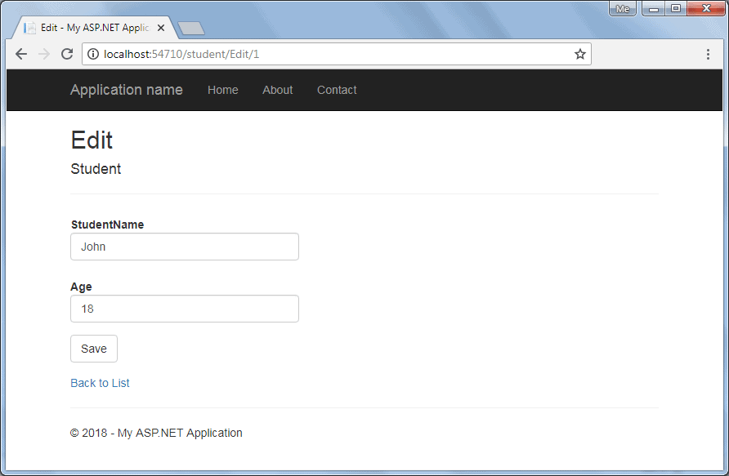 Edit View

The following figure describes how the edit functionality would work in ASP.NET MVC application.

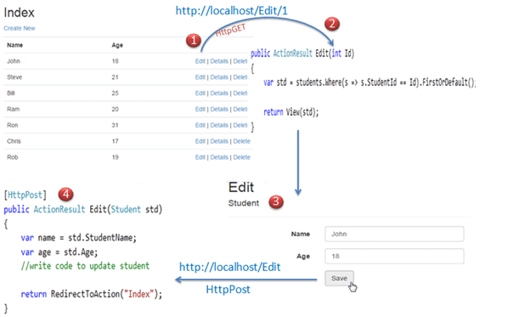

Editing Steps in ASP.NET MVC App

The above figure illustrates the following steps.

1. The user clicks on the Edit link in the student list view, which will send the HttpGET request http://localhost/student/edit/{Id} with corresponding Id parameter in the query string. This request will be handled by the HttpGET action method Edit(). (by default action method handles the HttpGET request if no attribute specified)
2. The HttpGet action method Edit() will fetch student data from the database, based on the supplied Id parameter and render the Edit view with that particular Student data.
3. The user can edit the data and click on the Save button in the Edit view. The Save button will send a HttpPOST request *http://localhost/Student/Edit* with the Form data collection.
4. The HttpPOST Edit action method in StudentController will finally update the data into the database and render an Index page with the refreshed data using the RedirectToAction method as a fourth step.

So, this will be the complete process to edit the data using the Edit view in ASP.NET MVC.

So, let's start to implement the above steps.

The following is the Student model class.

Example: Model Class

**namespace** MVCTutorials.Controllers

{

**public class** Student

{

**public int** StudentId { get; set; }

[Display( Name="Name")]

**public string** StudentName { get; set; }

**public int** Age { get; set; }

}

}

**Step: 1**

We have already created the student list view in the Create a View chapter, which includes the Edit action links for each Student, as shown below.



List View

In the above list view, edit links send HttpGet request to the Edit() action method of the StudentController with corresponding StudentId in the query string. For example, an edit link with a student John will append a StudentId to the request url because John's StudentId is 1 e.g. http://localhost:<port number>/edit/1.

**Step 2:**

Now, create a HttpGET action method Edit(int id) in the StudentController, as shown below.

Example: HttpGet Edit() Action method - C#

**using** MVCTutorials.Models;

**namespace** MVCTutorials.Controllers

{

**public class** StudentController : Controller

{

**static** IList<Student> studentList = **new** List<Student>{

**new** Student() { StudentId = 1, StudentName = "John", Age = 18 } ,

**new** Student() { StudentId = 2, StudentName = "Steve", Age = 21 } ,

**new** Student() { StudentId = 3, StudentName = "Bill", Age = 25 } ,

**new** Student() { StudentId = 4, StudentName = "Ram" , Age = 20 } ,

**new** Student() { StudentId = 5, StudentName = "Ron" , Age = 31 } ,

**new** Student() { StudentId = 4, StudentName = "Chris" , Age = 17 } ,

**new** Student() { StudentId = 4, StudentName = "Rob" , Age = 19 }

};

// GET: Student

**public** ActionResult Index()

{

//fetch students from the DB using Entity Framework here

**return** View(studentList.OrderBy(s => s.StudentId).ToList());

}

**public** ActionResult Edit(**int** Id)

{

//here, get the student from the database in the real application

//getting a student from collection for demo purpose

**var** std = studentList.Where(

s => s.StudentId == Id).FirstOrDefault();

**return** View(std);

}

}

}

The HttpGet Edit() action method must perform two tasks. First, it should fetch a student data from the underlying data source, whose StudentId matches the parameter Id. Second, it should render the Edit view with the data, so that the user can edit it.

In the above Edit() action method, a LINQ query is used to get a Student from the studentList collection whose StudentId matches with the parameter Id, and then pass that std object into View(std) to populate the edit view with this data. In a real-life application, you can get the data from the database instead of the sample collection.

At this point, if you run the application and click on the Edit link in the student list view, then you will get the following error.

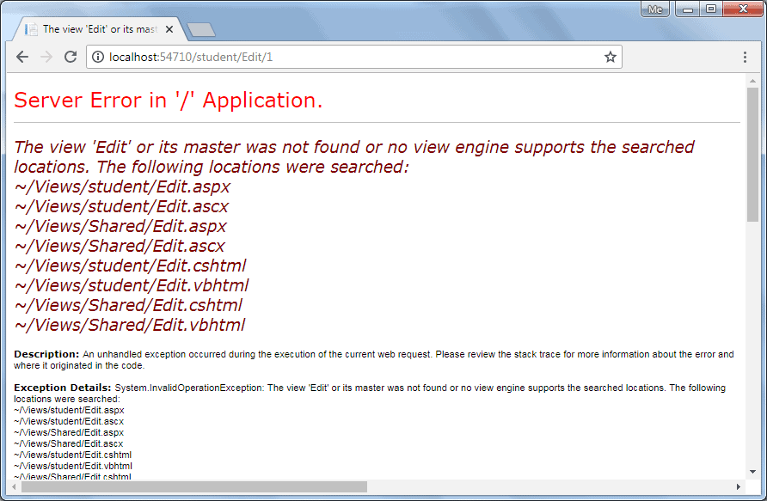Edit View Error

The above error occurrs because we have not created an Edit view yet. By default, MVC framework will look for Edit.cshtml, Edit.vbhtml, Edit.aspx, or Edit.ascx file in **/View/Student** or **/View/Shared** folder.

**Step 3:**

To create Edit view, right-click in the Edit() action method and click on **Add View..**. It will open Add View dialogue, as shown below.

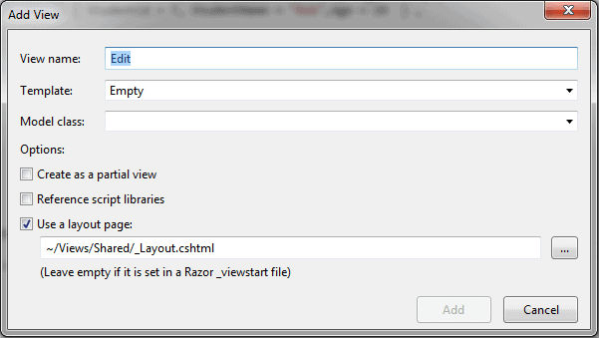 Create Edit View

In the Add View dialogue, keep the view name as Edit.

Select Edit Template and Student Model class from dropdown, as shown below.

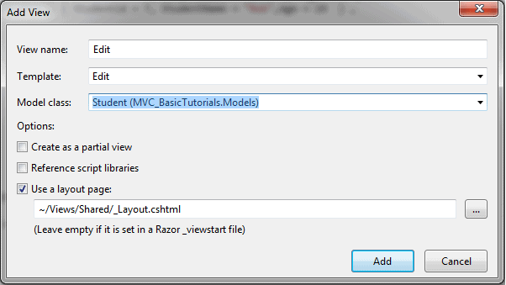

Select Edit Template and Model

Click **Add** button to generate the Edit.cshtml view under **/View/Student** folder, as shown below.

/View/Student/Edit.cshtml

@model MVCTutorials.Models.Student

@{

ViewBag.Title = "Edit";

Layout = "~/Views/Shared/\_Layout.cshtml";

}

**<h2>**Edit**</h2>**

@using (Html.BeginForm())

{

@Html.AntiForgeryToken()

**<div** **class**="form-horizontal"**>**

**<h4>**Student**</h4>**

**<hr />**

@Html.ValidationSummary(true, "", new { @class = "text-danger" })

@Html.HiddenFor(model =**>** model.StudentId)

**<div** **class**="form-group"**>**

@Html.LabelFor(model =**>** model.StudentName,

htmlAttributes: new { @class = "control-label col-md-2" })

**<div** **class**="col-md-10"**>**

@Html.EditorFor(model =**>** model.StudentName,

new { htmlAttributes = new { @class = "form-control" } })

@Html.ValidationMessageFor(model =**>** model.StudentName,

"", new { @class = "text-danger" })

**</div>**

**</div>**

**<div** **class**="form-group"**>**

@Html.LabelFor(model =**>** model.Age, htmlAttributes:

new { @class = "control-label col-md-2" })

**<div** **class**="col-md-10"**>**

@Html.EditorFor(model =**>** model.Age,

new { htmlAttributes = new { @class = "form-control" } })

@Html.ValidationMessageFor(model =**>** model.Age, "",

new { @class = "text-danger"< })

**</div>**

**</div>**

**<div** **class**="form-group"**>**

**<div** **class**="col-md-offset-2 col-md-10"**>**

**<input** **type**="submit" **value**="Save" **class**="btn btn-default" **/>**

**</div>**

**</div>**

**</div>**

}

**<div>**

@Html.ActionLink("Back to List", "Index")

**</div>**

Please notice that Edit.cshtml includes the HtmlHelper method Html.BeginForm() to create the HTML form tag. Html.BeginForm sends a HttpPost request by default. This will display a Student data when you click an edit link in the student list view, as shown below.

Edit View

You can now edit the data and click on the Save button. The Save button should send the HttpPOST request because we need to submit the form data as a part of the request body as a Student object.

**Step 4:**

Now, write HttpPost action method Edit() to save the edited student object, as shown below. So, there will be two Edit() action methods, HttpGet and HttpPost action methods.

Example: Controller Class in C#

**using** MVCTutorials.Models;

**namespace** MVCTutorials.Controllers

{

**public class** StudentController : Controller

{

IList<Student> studentList = **new** List<Student>() {

**new** Student(){ StudentId=1, StudentName="John", Age = 18 },

**new** Student(){ StudentId=2, StudentName="Steve", Age = 21 },

**new** Student(){ StudentId=3, StudentName="Bill", Age = 25 },

**new** Student(){ StudentId=4, StudentName="Ram", Age = 20 },

**new** Student(){ StudentId=5, StudentName="Ron", Age = 31 },

**new** Student(){ StudentId=6, StudentName="Chris", Age = 17 },

**new** Student(){ StudentId=7, StudentName="Rob", Age = 19 }

};

// GET: Student

**public** ActionResult Index()

{

**return** View(studentList.OrderBy(s => s.StudentId).ToList());

}

**public** ActionResult Edit(**int** Id)

{

//here, get the student from the database in the real application

//getting a student from collection for demo purpose

**var** std = studentList.Where(

s => s.StudentId == Id).FirstOrDefault();

**return** View(std);

}

[HttpPost]

**public** ActionResult Edit(Student std)

{

//update student in DB using EntityFramework in real-life application

//update list by removing old student and adding updated student for

// demo purpose

**var** student = studentList.Where(

s => s.StudentId == std.StudentId).FirstOrDefault();

studentList.Remove(student);

studentList.Add(std);

**return** RedirectToAction("Index");

}

}

}

In the above example, the HttpPost Edit() action method requires an object of the Student as a parameter. The Edit() view will bind the form's data collection to the student model parameter because it uses HTML helper methods @Html.EditorFor() for each properties to show input textboxes. Visit Model Binding section to know how MVC framework binds form data to action method parameter.

After updating the data in the DB, redirect back to the Index() action method to show the updated student list.

In this way, you can provide edit functionality using a default scaffolding Edit template.

# Razor Syntax

Razor is one of the view engines supported in ASP.NET MVC. Razor allows you to write a mix of HTML and server-side code using C# or Visual Basic. Razor view with visual basic syntax has .vbhtml file extension and C# syntax has .cshtml file extension.

Razor syntax has the following Characteristics:

* **Compact**: Razor syntax is compact, enabling you to minimize the number of characters and keystrokes required to write code.
* **Easy to Learn**: Razor syntax is easy to learn where you can use your familiar language C# or Visual Basic.
* **Intellisense**: Razor syntax supports statement completion within Visual Studio.

## **Inline expression**

Start with @ symbol to write server-side C# or VB code with HTML code. For example, write @Variable\_Name to display the value of a server-side variable, e.g., DateTime.Now returns the current date and time. So, write @DateTime.Now to display the current date and time, as shown below. A single line expression does not require a semicolon at the end of the expression.

C# Razor Syntax

**<h1>**Razor syntax demo**</h1>**

**<h2>**@DateTime.Now.ToShortDateString()**</h2>**

Output:

**Razor syntax demo**

08-09-2014

## **Multi-statement Code block**

You can write multiple lines of server-side code enclosed in braces @{ ... }. Each line must ends with a semicolon the same as C#.

Example: Server side Code in Razor Syntax

@{

var date = DateTime.Now.ToShortDateString();

var message = "Hello World";

}

**<h2>**Today's date is: @date **</h2>**

**<h3>**@message**</h3>**

Output:

Today's date is: 08-09-2014

Hello World!

## **Display Text from Code Block**

Use @: or <text>/<text> to display texts within code block.

Example: Display Text in Razor Syntax

@{

var date = DateTime.Now.ToShortDateString();

string message = "Hello World!";

@:Today's date is: @date **<br />**

@message

}

Output:

Today's date is: 08-09-2014

Hello World!

Display text using <text> within a code block, as shown below.

Example: Text in Razor Syntax

@{

var date = DateTime.Now.ToShortDateString();

string message = "Hello World!";

**<text>**Today's date is:**</text>** @date **<br />**

@message

}

Output:

Today's date is: 08-09-2014

Hello World!

## **if-else condition**

Write if-else condition starting with @ symbol. The if-else code block must be enclosed in braces { }, even for a single statement.

Example: if else in Razor

@if(DateTime.IsLeapYear(DateTime.Now.Year) )

{

@DateTime.Now.Year @:is a leap year.

}

else {

@DateTime.Now.Year @:is not a leap year.

}

Output:

2014 is not a leap year.

## **for loop**

Example: for loop in Razor

@for (int i = 0; i < 5; i++) {

@i.ToString() **<br />**

}

Output:

0

1

2

3

4

## **Model**

Use @model to use model object anywhere in the view.

Example: Use Model in Razor

@model Student

**<h2>**Student Detail:**</h2>**

**<ul>**

**<li>**Student Id: @Model.StudentId**</li>**

**<li>**Student Name: @Model.StudentName**</li>**

**<li>**Age: @Model.Age**</li>**

**</ul>**

Output:

**Student Detail:**

- Student Id: 1

- Student Name: John

- Age: 18

## **Declare Variables**

Declare a variable in a code block enclosed in brackets and then use those variables inside HTML with @ symbol.

Example: Variable in Razor

@{

string str = "";

if(1 **>** 0)

{

str = "Hello World!";

}

}

**<p>**@str**</p>**

Output:

Hello World!

Learn more about [razor syntax](https://docs.microsoft.com/en-us/aspnet/web-pages/overview/getting-started/introducing-razor-syntax-c) on docs.microsoft.com.

# HTML Helpers

Here, you will learn what HTML helpers are and how to use them in the razor view.

The HtmlHelper class renders HTML controls in the razor view. It binds the model object to HTML controls to display the value of model properties into those controls and also assigns the value of the controls to the model properties while submitting a web form. So always use the HtmlHelper class in razor view instead of writing HTML tags manually.

The following figure shows the use of the HtmlHelper class in the razor view.

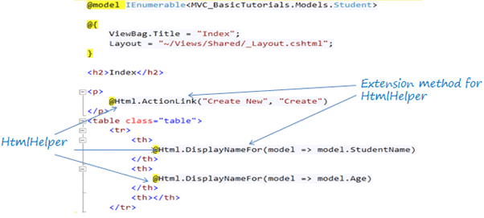HTML Helpers

In the above figure, **@Html** is an object of the HtmlHelper class. (@ symbol is used to access server-side object in razor syntax). Html is a property of the HtmlHelper class included in base class of razor view WebViewPage. The ActionLink() and DisplayNameFor() are extension methods included in the HtmlHelper class.

The HtmlHelper class generates HTML elements. For example, @Html.ActionLink("Create New", "Create") would generate anchor tag <a href="/Student/Create">Create New</a>.

There are many [extension methods for HtmlHelper](https://docs.microsoft.com/en-us/previous-versions/aspnet/dd493095(v=vs.118)) class, which creates different HTML controls.

The following table lists the HtmlHelper methods and HTML control each method renders.

| **Extension Method** | **Strongly Typed Method** | **Html Control** |
| --- | --- | --- |
| Html.ActionLink() | NA | <a></a> |
| Html.TextBox() | Html.TextBoxFor() | <input type="textbox"> |
| Html.TextArea() | Html.TextAreaFor() | <input type="textarea"> |
| Html.CheckBox() | Html.CheckBoxFor() | <input type="checkbox"> |
| Html.RadioButton() | Html.RadioButtonFor() | <input type="radio"> |
| Html.DropDownList() | Html.DropDownListFor() | <select> <option> </select> |
| Html.ListBox() | Html.ListBoxFor() | multi-select list box: <select> |
| Html.Hidden() | Html.HiddenFor() | <input type="hidden"> |
| Html.Password() | Html.PasswordFor() | <input type="password"> |
| Html.Display() | Html.DisplayFor() | HTML text: "" |
| Html.Label() | Html.LabelFor() | <label> |
| Html.Editor() | Html.EditorFor() | Generates Html controls based on data type of specified model property e.g. textbox for string property, numeric field for int, double or other numeric type. |

The difference between calling the HtmlHelper methods and using an HTML tags is that the HtmlHelper method is designed to make it easy to bind to view data or model data.

Learn about various HtmlHelper methods in the next few sections.

# Create a Textbox in ASP.NET MVC

The HtmlHelper class includes two extension methods TextBox() and TextBoxFor<TModel, TProperty>() that renders the HTML textbox control <input type="text"> in the razor view.

It is recommended to use the generic TextBoxFor<TModel, TProperty>() method, which is less error prons and performs fast.

We will use the following Student model class throughout this article.

Example: Student Model

**public class** Student

{

**public int** StudentId { get; set; }

[Display(Name="Name")]

**public string** StudentName { get; set; }

**public int** Age { get; set; }

**public bool** isNewlyEnrolled { get; set; }

**public string** Password { get; set; }

}

## **Html.TextBoxFor()**

The TextBoxFor<TModel, TProperty>() is the generic extension method that creates <input type="text"> control. The first type parameter is for the model class, and second type parameter is for the property.

TextBoxFor() Signature

**public static** MvcHtmlString TextBoxFor<TModel,TProperty> (**this** HtmlHelper<TModel>> htmlHelper, Expression<Func<TModel,TProperty>> expression, **object** htmlAttributes);

There are other overloads of the TextBoxFor() method. Visit docs.microsoft.com to know all the [overloads of TextBoxFor() method](https://docs.microsoft.com/en-us/dotnet/api/system.web.mvc.html.inputextensions.textboxfor?view=aspnet-mvc-5.2).

The following example shows how to render a textbox for the StudentName property of the Student model.

Example: TextBoxFor() in Razor View

@model Student

@Html.TextBoxFor(m =**>** m.StudentName)

In the above example, the lambda expression m => m.StudentName specifies the StudentName property to bind with a textbox. It generates an input text element with id and name attributes, as shown below.

Html Result:

**<input** **id**="StudentName" **name**="StudentName" **type**="text" **value**="" **/>**

The following example renders a textbox with the class attribute.

Example: TextBoxFor() in Razor View

@model Student

@Html.TextBoxFor(m =**>** m.StudentName, new { @class = "form-control" })

Html Result:

**<input** **class**="form-control" **id**="StudentName" **name**="StudentName" **type**="text" **value**="" **/>**

## **Html.TextBox()**

The TextBox() method creates <input type="text" > HTML control with the specified name, value, and other attributes.

TextBoxFor() Signature

**public static** MvcHtmlString TextBox(**this** HtmlHelper htmlHelper, **string** name, **string value**, **object** htmlAttributes)

Visit docs.microsoft.com to know all the [overloads of TextBox() method](https://docs.microsoft.com/en-us/previous-versions/aspnet/dd505176(v=vs.100)).

The TextBox() method is a loosely typed method because the name parameter is a string. The name parameter can be a property name of a model object. It binds specified property with a textbox. So it automatically displays the value of the model property in a textbox and visa-versa.

Example: Html.TextBox() in Razor View

@model Student

@Html.TextBox("StudentName")

Html Result:

**<input** **id**="StudentName" **name**="StudentName" **type**="text" **value**="" **/>**

# Create TextArea in ASP.NET MVC

The HtmlHelper class includes two extension methods to render multi-line <textarea> HTML control in a razor view: TextArea() and TextAreaFor<TModel, TProperty>(). By default, it creates a textarea with rows=2 and cols=20.

We will use the following Student model class throughout this article.

Example: Student Model

**public class** Student

{

**public int** StudentId { get; set; }

[Display(Name="Name")]

**public string** StudentName { get; set; }

**public string** Description { get; set; }

}

## **Html.TextAreaFor()**

The TextAreaFor<TModel, TProperty>() is the generic extension method that creates <textarea></textarea> control.

It is recommended to use the generic TextAreaFor<TModel, TProperty>() method, which is less error prons and performs fast.

TextAreaFor() Signature

**public static** MvcHtmlString TextAreaFor<TModel,TProperty> (**this** HtmlHelper<TModel>> htmlHelper, Expression<Func<TModel,TProperty>> expression, **object** htmlAttributes);

Visit docs.microsoft.com to know all the [overloads of TextAreaFor()](https://docs.microsoft.com/en-us/dotnet/api/system.web.mvc.html.textareaextensions?view=aspnet-mvc-5.2).

The following example creates and binds the Description property to a textarea control in the MVC view.

Example: TextAreaFor() in Razor View

@model Student

@Html.TextAreaFor(m =**>** m.Description)

Html Result:

**<textarea** **cols**="20" **id**="Description" **name**="Description" **rows**="2"**></textarea>**

The following example renders a textarea with the class attribute.

Example: TextAreaFor() in Razor View

@model Student

@Html.TextAreaFor(m =**>** m.Description, new { @class = "form-control" })

In the above example, the first parameter m => m.Description is a lambda expression that specifies the model property to bind with the textarea element. The second parameter specifies the class attribute.

Html Result:

**<textarea** **class**="form-control" **cols**="20" **id**="Description" **name**="Description" **rows**="2"**></textarea>**

## **Html.TextArea()**

The Html.TextArea() method creates a <textarea> HTML control with specified name, value and html attributes.

The TextArea() method is a loosely typed method because the name parameter is a string. The name parameter can be a property name of the model class.

Example: Html.TextArea() in Razor View

@model Student

@Html.TextArea("Description", "This is dummy description.", new { @class = "form-control" })

Html Result:

**<textarea** **class**="form-control" **id**="Description" **name**="Description" **rows**="2"**cols**="20"**>**This is dummy description.**</textarea>**

# Create Checkbox in ASP.NET MVC

The HtmlHelper class includes two extension methods to generate a <input type="checkbox"> HTML control in a razor view: CheckBox() and CheckBoxFor().

We will use the following Student model class throughout this article.

Example: Student Model

**public class** Student

{

**public int** StudentId { get; set; }

[Display(Name="Name")]

**public string** StudentName { get; set; }

**public bool** isActive { get; set; }

}

## **Html.CheckBoxFor()**

The CheckBoxFor<TModel, TProperty>() extension method generates <input type="checkbox"> control for the model property specified using a lambda expression.

Visit docs.microsoft.com to know all the [overloads of CheckBoxFor() method](https://docs.microsoft.com/en-us/dotnet/api/system.web.mvc.html.inputextensions.checkbox?view=aspnet-mvc-5.2).

Example: Html.CheckBoxFor() in Razor View

@model Student

@Html.CheckBoxFor(m => m.isActive)

Html Result:

**<input** **data-val**="true"

**data-val-required**="The isActive field is required."

**id**="isActive"

**name**="isActive"

**type**="checkbox"

**value**="true" **/>**

**<input** **name**="isActive" **type**="hidden" **value**="false" **/>**

In the above example, the first parameter is a lambda expression that specifies the model property to bind with the checkbox element. We have specified isActive property in the above example.

Notice that it has generated an additional hidden field with the same name and value=false. When you submit a form with a checkbox, the value is posted only if a checkbox is checked. So, if you leave the checkbox unchecked, then nothing will be sent to the server. Sometimes, you would want false to be sent to the server. Because, an hidden input has the same name, it will send false to the server if checkbox is unchecked.

## **Html.CheckBox()**

The Html.CheckBox() is a loosely typed method which generates a <input type="checkbox" > with the specified name, isChecked boolean, and HTML attributes.

Example: Html.CheckBox() in Razor View

@Html.CheckBox("isActive", **true**)

Html Result:

**<input** **checked**="checked"

**id**="isActive"

**name**="isActive"

**type**="checkbox"

**value**="true" **/>**

# Create Radio buttons in ASP.NET MVC

Learn how to generate radio button control using the HtmlHelper in razor view in this section.

The HtmlHelper class include two extension methods to generate a <input type="radio"> HTML control in a razor view: RadioButtonFor() and RadioButton() .

We will use the following Student model class throughout this article.

Example: Student Model

**public class** Student

{

**public int** StudentId { get; set; }

**public string** StudentName { get; set; }

**public string** Gender { get; set; }

}

## **Html.RadioButtonFor()**

The Html.RadioButtonFor<TModel, TProperty>() extension method is a strongly typed extension method. It generates <input type="radio"> control for the property specified using a lambda expression.

Visit docs.microsoft.com to know all the [overloads of RadioButtonFor()](https://docs.microsoft.com/en-us/dotnet/api/system.web.mvc.html.inputextensions.radiobuttonfor?view=aspnet-mvc-5.2).

Example: Html.RadioButtonFor() in Razor View

@model Student

@Html.RadioButtonFor(m => m.Gender,"Male")

@Html.RadioButtonFor(m => m.Gender,"Female")

Html Result:

**<input** **checked**="checked"

**id**="Gender"

**name**="Gender"

**type**="radio"

**value**="Male" **/>**

**<input** **id**="Gender"

**name**="Gender"

**type**="radio"

**value**="Female" **/>**

In the above example, the first parameter is a lambda expression that specifies the model property to be bind with a radio button control. We have created two radio buttons for the Gender property in the above example. So, it generates two <input type="RadioButton"> controls with id and name set to property name Gender. The second parameter is a value that will be sent to the server when the form is submitted, here Male will be sent if the first radio button selected, and Female will be sent if the second radio button selected.

## **RadioButton()**

The Html.RadioButton() method creates a radio button element with a specified name, isChecked boolean and html attributes.

Visit docs.microsoft.com to know all the [overloads of RadioButton() method](https://docs.microsoft.com/en-us/dotnet/api/system.web.mvc.html.inputextensions.radiobutton?view=aspnet-mvc-5.2).

Example: Html.RadioButton() in Razor View

Male: @Html.RadioButton("Gender","Male")

Female: @Html.RadioButton("Gender","Female")

Html Result:

Male: **<input** **checked**="checked"

**id**="Gender"

**name**="Gender"

**type**="radio"

**value**="Male" **/>**

Female: **<input** **id**="Gender"

**name**="Gender"

**type**="radio"

**value**="Female" **/>**

# Create DropdownList in ASP.NET MVC

Learn how to generate the dropdownlist HTML control using the HtmlHelper in a razor view.

The [HtmlHelper](https://docs.microsoft.com/en-us/dotnet/api/system.web.mvc.htmlhelper?view=aspnet-mvc-5.2" \t "_blank) class includes two extension methods to generate the <select> control in a razor view: DropDownListFor() and DropDownList().

We will use the following Student model class and Gender enum.

Example: Student Model

**public class** Student

{

**public int** StudentId { get; set; }

**public string** StudentName { get; set; }

**public** Gender StudentGender { get; set; }

}

**public enum** Gender

{

Male,

Female

}

## **Html.DropDownListFor()**

The Html.DropDownListFor<TModel,TProperty> extension method is a strongly typed extension method generates <select> element for the property specified using a lambda expression.

Visit docs.microsoft.com to know all the [overloads of DropDownListFor](https://docs.microsoft.com/en-us/dotnet/api/system.web.mvc.html.selectextensions.dropdownlistfor?view=aspnet-mvc-5.2) method.

The following example creates dropdown list for the above StudentGender property.

Example: Html.DropDownListFor() in Razor View

@**using** MyMVCApp.Models

@model Student

@Html.DropDownListFor(m => m.StudentGender,

**new** SelectList(Enum.GetValues(**typeof**(Gender))),

"Select Gender")

Html Result:

**<select** **class**="form-control" **id**="StudentGender" **name**="StudentGender"**>**

**<option>**Select Gender**</option>**

**<option>**Male**</option>**

**<option>**Female**</option>**

**</select>**

In the above example, the first parameter in DropDownListFor() method is a lambda expression that specifies the model property to be bind with the select element. We have specified the StudentGender property. The second parameter specifies the items to show into a dropdown list using SelectList object. The third parameter is optional, which will be the first item of dropdownlist. So now, it generates <select> control with two list items - Male & Female, as shown below.

## dropdown list in mvc

## **Html.DropDownList()**

The Html.DropDownList() method generates a <select> element with specified name, list items and html attributes.

Visit docs.microsoft.com to know all the [overloads of DropDownList() method](https://docs.microsoft.com/en-us/dotnet/api/system.web.mvc.html.selectextensions.dropdownlist?view=aspnet-mvc-5.2).

Example: Html.DropDownList() in Razor View

@**using** MyMVCApp.Models

@model Student

@Html.DropDownList("StudentGender",

**new** SelectList(Enum.GetValues(**typeof**(Gender))),

"Select Gender",

**new** { @class = "form-control" })

Html Result:

**<select** **class**="form-control" **id**="StudentGender" **name**="StudentGender"**>**

**<option>**Select Gender**</option>**

**<option>**Male**</option>**

**<option>**Female**</option>**

**</select>**

In the above example, the first parameter is a property name for which we want to display list items. The second parameter is a list of values to be included in the dropdown list. We have used Enum methods to get the Gender values. The third parameter is a label, which will be the first list item, and the fourth parameter is for HTML attributes like CSS to be applied on the dropdown list.

# Create a Hidden Field in ASP.NET MVC

Learn how to generate hidden field using the HtmlHelper in razor view in this section.

The HtmlHelper class includes two extension methods to generate a hidden field <input type="hidden"> element in a razor view: HiddenFor() and Hidden().

We will use the following Student model class throughout this article.

Example: Student Model

**public class** Student

{

**public int** StudentId { get; set; }

**public string** StudentName { get; set; }

}

## **Html.HiddenFor()**

The Html.HiddenFor<TModel, TProperty> extension method is a strongly typed extension method generates a hidden input element for the model property specified using a lambda expression.

Visit docs.microsoft.com to know all the [overloads of HiddenFor() method](https://docs.microsoft.com/en-us/dotnet/api/system.web.mvc.html.inputextensions.hiddenfor?view=aspnet-mvc-5.2).

Example: HiddenFor() in Razor View

@model Student

@Html.HiddenFor(m => m.StudentId)

Html Result:

**<input** **data-val**="true"

**data-val-number**="The field StudentId must be a number."

**data-val-required**="The StudentId field is required."

**id**="StudentId"

**name**="StudentId"

**type**="hidden"

**value**="" **/>**

In the above example, the first parameter in HiddenFor() method is a lambda expression that specifies the model property to be bind with the hidden field. We have specified the StudentId property in the above example. So, it generates an input text element with id & name set to the property name. The value attribute will be set to the value of the StudentId property.

Please notice that it has created data- HTML5 attribute, which is used for the validation in ASP.NET MVC.

## **Html.Hidden()**

The Html.Hidden() method generates an input hidden field element with specified name, value and html attributes.

Visit MSDN to know all the [overloads of Hidden() method](https://docs.microsoft.com/en-us/dotnet/api/system.web.mvc.html.inputextensions.hidden?view=aspnet-mvc-5.2).

Example: Html.Hidden() in Razor View

@model Student

@Html.Hidden("StudentId")

Html Result:

**<input** **id**="StudentId"

**name**="StudentId"

**type**="hidden"

**value**="1" **/>**

# Create Password field in ASP.NET MVC

The HtmlHelper class includes two extension methods to generate a password field <input type="password"> element in a razor view: Password() and PasswordFor().

We will use following User model with Password() and PasswordFor() method.

Example: User Model

**public class** User

{

**public int** UserId { get; set; }

**public string** Password { get; set; }

}

## **Html.PasswordFor()**

The Html.PasswordFor<TModel,TProperty>() extension method is a strongly typed extension method. It generates a <input type="password"> element for the model object property specified using a lambda expression.

Visit docs.microsoft.com to know all the [overloads of PasswordFor() method](https://docs.microsoft.com/en-us/dotnet/api/system.web.mvc.html.inputextensions.passwordfor?view=aspnet-mvc-5.2).

Example: PasswordFor() in Razor View

@model User

@Html.PasswordFor(m => m.Password)

Html Result:

**<input** **id**="Password" **name**="Password" **type**="password" **value**="" **/>**

In the above example, the first parameter in PasswordFor() method is a lambda expression that specifies the model property to be bind with the password textbox. We have specified the Password property. It generates the following result.

[password input field](https://www.tutorialsteacher.com/Content/images/mvc/htmlhelper-password.png)

## **Html.Password()**

The Html.Password() method generates a input password element with specified name, value and html attributes.

Visit docs.microsoft.com to know all the [overloads of Password() method](https://docs.microsoft.com/en-us/dotnet/api/system.web.mvc.html.inputextensions.password?view=aspnet-mvc-5.2).

Example: Html.Password() in Razor View

@model User

@Html.Password("Password")

Html Result:

**<input**

**id**="Password"

**name**="Password"

**type**="password"

**value**="" **/>**

# HtmlHelper - Display HTML String

Learn how to create html string literal using the HtmlHelper class in razor view.

The HtmlHelper class includes two extension methods to generate html string : Display() and DisplayFor().

We will use the following model class with the Display() and DisplayFor() method.

Example: Student Model

**public class** Student

{

**public int** StudentId { get; set; }

**public string** StudentName { get; set; }

**public int** Age { get; set; }

}

## **Html.DisplayFor()**

The DisplayFor() helper method is a strongly typed extension method. It generates a html string for the model object property specified using a lambda expression.

DisplayFor() method Signature: MvcHtmlString DisplayFor(<Expression<Func<TModel,TValue>> expression)

Visit MSDN to know all the [overloads of DisplayFor() method](https://docs.microsoft.com/en-us/dotnet/api/system.web.mvc.html.displayextensions.displayfor?view=aspnet-mvc-5.2).

Example: DisplayFor() in Razor View

@model Student

@Html.DisplayFor(m => m.StudentName)

Html Result:

"Steve"

In the above example, we have specified StudentName property of Student model using lambda expression in the DisplayFor() method. So, it generates a html string with the StudentName value, Steve, in the above example.

## **Display()**

The Html.Display() is a loosely typed method which generates a string in razor view for the specified property of model.

Display() method Signature: MvcHtmlString Display(string expression)

Visit docs.microsoft.com to know all the [overloads of Display() method](https://docs.microsoft.com/en-us/dotnet/api/system.web.mvc.html.displayextensions.display?view=aspnet-mvc-5.2)

Example: Html.Display() in Razor View

@Html.Display("StudentName")

Html Result:

"Steve"

# Create Label in ASP.NET MVC

The HtmlHelper class includes two extension methods to generate HTML label element: Label() and LabelFor().

We will use the following Student model class.

Example: Student Model

**public class** Student

{

**public int** StudentId { get; set; }

[Display(Name="Name")]

**public string** StudentName { get; set; }

**public int** Age { get; set; }

}

## **Html.LabelFor()**

The Html.LabelFor<TModel,TProperty>() helper method is a strongly typed extension method. It generates a html label element for the model object property specified using a lambda expression.

Visit MSDN to know all the [overloads of LabelFor() method](https://docs.microsoft.com/en-us/dotnet/api/system.web.mvc.html.labelextensions.labelfor?view=aspnet-mvc-5.2).

Example: LabelFor() in Razor View

@model Student

@Html.LabelFor(m => m.StudentName)

Html Result:

**<label** **for**="StudentName"**>**Name**</label>**

In the above example, we have specified the StudentName property using a lambda expression in the LabelFor() method. The Display attribute on the StudentName property will be used as a label.

## **Label()**

The Html.Label() method generates a <label> element for a specified property of model object.

Visit MSDN to know all the [overloads of Label() method](https://docs.microsoft.com/en-us/dotnet/api/system.web.mvc.html.labelextensions.label?view=aspnet-mvc-5.2)

Example: Html.Label() in Razor View

@Html.Label("StudentName")

Html Result:

**<label** **for**="StudentName"**>**Name**</label>**

You can specify another label text instead of property name as shown below.

Example: Html.Label() in Razor View

@Html.Label("StudentName","Student Name")

Html Result:

**<label** **for**="StudentName"**>**Student Name**</label>**

# Create HTML Controls for Model Class Properties using EditorFor()

ASP.NET MVC includes the method that generates HTML input elements based on the datatype. The Html.Editor() or Html.EditorFor() extension methods generate HTML elements based on the data type of the model object's property.

The following table list the data types and releted HTML elements:

| DataType | Html Element |
| --- | --- |
| string | <input type="text" > |
| int | <input type="number" > |
| decimal, float | <input type="text" > |
| boolean | <input type="checkbox" > |
| Enum | <input type="text" > |
| DateTime | <input type="datetime" > |

We will use the following model class.

Example: Student Model

**public class** Student

{

**public int** StudentId { get; set; }

[Display(Name="Name")]

**public string** StudentName { get; set; }

**public int** Age { get; set; }

**public bool** isNewlyEnrolled { get; set; }

**public string** Password { get; set; }

**public** DateTime DoB { get; set; }

}

## **Html.EditorFor()**

The Html.EditorFor() method is a strongly typed method. It requires the lambda expression to specify a property of the model object.

Visit MSDN to know all the [overloads of EditorFor() method](https://docs.microsoft.com/en-us/dotnet/api/system.web.mvc.html.editorextensions.editorfor?view=aspnet-mvc-5.2)

Example: EditorFor() in Razor view

@model Student

StudentId: @Html.EditorFor(m =**>** m.StudentId) **<br />**

Student Name: @Html.EditorFor(m =**>** m.StudentName) **<br />**

Age: @Html.EditorFor(m =**>** m.Age)**<br />**

Password: @Html.EditorFor(m =**>** m.Password)**<br />**

isNewlyEnrolled: @Html.EditorFor(m =**>** m.isNewlyEnrolled)**<br />**

DoB: @Html.EditorFor(m =**>** m.DoB)

Html Result:

StudentId: **<input** **data-val**="true" **data-val-number**="The field StudentId must be a number." **data-val-required**="The StudentId field is required." **id**="StudentId" **name**="StudentId" **type**="number" **value**="" **/>**

Student Name: **<input** **id**="StudentName" **name**="StudentName" **type**="text" **value**="" **/>**

Age: **<input** **data-val**="true" **data-val-number**="The field Age must be a number." **data-val-required**="The Age field is required." **id**="Age" **name**="Age" **type**="number" **value**="" **/>**

Password: **<input** **id**="Password" **name**="Password" **type**="text" **value**="" **/>**

isNewlyEnrolled:**<input** **class**="check-box" **data-val**="true" **data-val-required**="The isNewlyEnrolled field is required." **id**="isNewlyEnrolled" **name**="isNewlyEnrolled" **type**="checkbox" **value**="true" **/>**

**<input** **name**="isNewlyEnrolled" **type**="hidden" **value**="false" **/>**

DoB: **<input** **data-val**="true" **data-val-date**="The field DoB must be a date." **data-val-required**="The DoB field is required." **id**="DoB" **name**="DoB" **type**="datetime" **value**="" **/>**

In the above exampl, MVC framework generates an appropriate control based on the data type of a property, e.g. textbox for string type property, number field for int type property, checkbox for boolean property, etc.

## **Html.Editor()**

The Html.Editor() method requires a string parameter to specify the property name. It creats a HTML element based on the datatype of the specified property, same as EditorFor() method.

Visit MSDN to know all the [overloads of Editor() method](https://msdn.microsoft.com/en-us/library/system.web.mvc.html.editorextensions.editor(v=vs.118).aspx)

Consider the following example to understand the Editor() method.

Example: Editor() in Razor view

StudentId: @Html.Editor("StudentId")

Student Name: @Html.Editor("StudentName")

Age: @Html.Editor("Age")

Password: @Html.Editor("Password")

isNewlyEnrolled:@Html.Editor("isNewlyEnrolled")

Gender: @Html.Editor("Gender")

DoB: @Html.Editor("DoB")

# Exception Handling in ASP.NET MVC

Here you will learn how to handle exceptions in ASP.NET MVC application.

You may handle all possible exceptions in the action methods using try-catch blocks. However, there can be some unhandled exceptions that you want to log and display custom error messages or custom error pages to users.

When you create an MVC application in Visual Studio, it does not implement any exception handling technique out of the box. It will display an error page when an exception occurred.

For example, consider the following action method that throws an exception.

Example: Action Method

**namespace** ExceptionHandlingDemo.Controllers

{

**public class** HomeController : Controller

{

**public** ActionResult Contact()

{

**string** msg = **null**;

ViewBag.Message = msg.Length; // this will throw an exception

**return** View();

}

}

Navigating to /home/contact in the browser, and you will see the following yellow page (also known as the Yellow Screen of Death) that shows exception details such as exception type, line number and file name where the exception occurred, and stack trace.

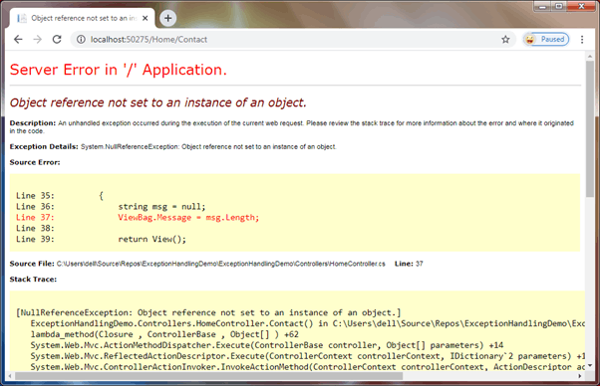Default Error Page in MVC

ASP.NET provides the following ways to handle exceptions:

1. Using <customErrors> element in web.config
2. Using HandleErrorAttribute
3. Overriding Controller.OnException method
4. Using Application\_Error event of HttpApplication

## **<customErrors> Element in web.config**

The <customErrors> element under system.web in web.config is used to configure error code to a custom page. It can be used to configure custom pages for any error code 4xx or 5xx. However, it cannot be used to log exception or perform any other action on exception.

Enable the <customErrors> in web.config, as shown below.

Example: Enable customErrors

**<system**.web**>**

**<customErrors** **mode**="On"**></customErrors>**

**</system**.web**>**

You also need to add HandleErrorAttribute filter in the FilterConfig.cs file.

Example: Add HandleErrorAttribute Filter

**public class** FilterConfig

{

**public static void** RegisterGlobalFilters(GlobalFilterCollection filters)

{

filters.Add(**new** HandleErrorAttribute());

}

}

After enabling the customErrors mode to On, an ASP.NET MVC application will show the default custom error page, as shown below.

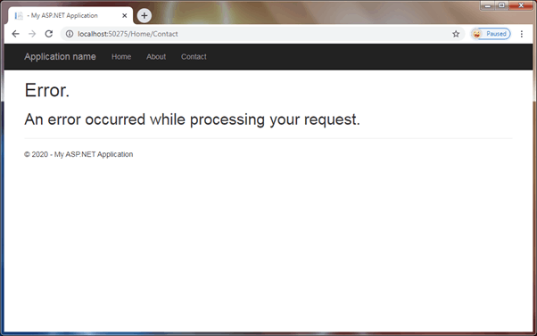Custom Error Page

The above view is Error.cshtml in the Shared folder. It will be displayed on the 500 error code.

The HandleErrorAttribute filter set the Error.cshtml as the default view to display on an error occurred.

## **HandleErrorAttribute**

The [HandleErrorAttribute](https://docs.microsoft.com/en-us/dotnet/api/system.web.mvc.handleerrorattribute?view=aspnet-mvc-5.2" \t "_blank) is an attribute that can be used to handle exceptions thrown by an action method or a controller. You can use it to display a custom view on a specific exception occurred in an action method or in an entire controller.

 Note:

The HandleErrorAttribute attribute can only be used to handle the exception with status code 500. Also, it does not provide a way to log exceptions.

In order to use this attribute, you must add HandleErrorAttribute filter in the FilterConfig.RegisterGlobalFilters() method and also, set the mode attribute to On <customErrors mode="On"> in web.config, as we did for the customErrors section above.

Now, let's apply [HandleError] attribute to the action method, as shown below.

Example: HandleErrorAttribute

**public class** HomeController : Controller

{

[HandleError]

**public** ActionResult Contact()

{

**string** msg = **null**;

ViewBag.Message = msg.Length;

**return** View();

}

}

Above, we configured [HandleError] attribute on the Contact() action method. It will display Error.cshtml view from the Shared folder when an exception occurs. The [HandleError] set the Error.cshtml view as default view for any exceptions.

the [HandleError] can also be used to configure different pages for different types of exceptions, as shown below.

Example: Configure Views for Exceptions

**public class** HomeController : Controller

{

[HandleError]

[HandleError(ExceptionType =**typeof**(NullReferenceException),

View ="~/Views/Error/NullReference.cshtml")]

**public** ActionResult Contact()

{

**string** msg = **null**;

ViewBag.Message = msg.Length;

**return** View();

}

}

Now, the above example will show NullReference.cshtml because it throws NullReferenceException.

The [HandleError] attribute has a limited scope and not recommended to use in most cases.

## **Overriding Controller.OnException Method**

Another way to handle controller level exceptions is by overriding the OnException() method in the controller class. This method handles all your unhandled errors with error code 500.

It allows you to log an exception and redirect to the specific view. It does not require to enable the <customErrors> config in web.config.

Example: Handle Exceptions in the Controller

**public class** HomeController : Controller

{

**public** ActionResult Contact()

{

**string** msg = **null**;

ViewBag.Message = msg.Length;

**return** View();

}

**protected override void** OnException(ExceptionContext filterContext)

{

filterContext.ExceptionHandled = **true**;

//Log the error!!

//Redirect to action

filterContext.Result = RedirectToAction("Error", "InternalError");

// OR return specific view

filterContext.Result = **new** ViewResult

{

ViewName = "~/Views/Error/InternalError.cshtml"

};

}

}

## **Using Application\_Error event of HttpApplication**

The ideal way to log exception occurred in any part of your MVC application is to handle it in the Application\_Error event in the global.asax file.

Example:

**public class** MvcApplication : System.Web.HttpApplication

{

//other code removed for clarity

**protected void** Application\_Error()

{

**var** ex = Server.GetLastError();

//log an exception

}

}

The Application\_Error event is fired on any type of exception and error codes. So, handle it carefully.

## **Recommendation**

In most web applications, you should ideally log the exceptions and also show appropriate error messages or pages to the users. So, it is recommended to use the global Application\_Error event to log all the exceptions along with <customErrors> element in web.config to redirect it to appropriate pages.

The above exception handling techniques will return the response with 200 status code. If you are concern to return specific error code in response then you have to use <httpErrors> element in web.config.

# Implement Data Validation in MVC

Here, you will learn how to implement the data validation and display validation messages on the violation of business rules in an ASP.NET MVC application.

The following image shows how the validation messages will be displayed if Name or Age fields are blank while creating or editing data.

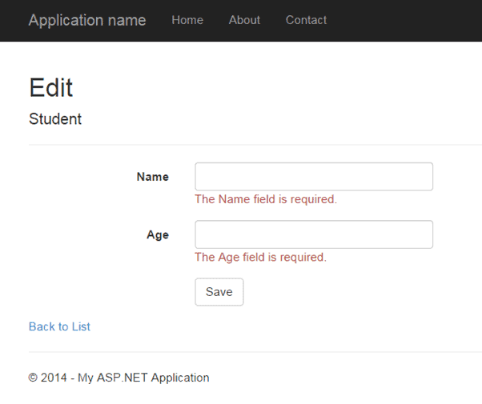

## **Validation using Data Annotation Attributes**

ASP.NET MVC includes built-in attribute classes in the [System.ComponentModel.DataAnnotations](https://docs.microsoft.com/en-us/dotnet/api/system.componentmodel.dataannotations?view=netframework-4.8" \t "_blank) namespace. These attributes are used to define metadata for ASP.NET MVC and ASP.NET data controls. You can apply these attributes to the properties of the model class to display appropriate validation messages to the users.

The following table lists all the data annotation attributes which can be used for validation.

| Attribute | Usage |
| --- | --- |
| Required | Specifies that a property value is required. |
| StringLength | Specifies the minimum and maximum length of characters that are allowed in a string type property. |
| Range | Specifies the numeric range constraints for the value of a property. |
| RegularExpression | Specifies that a property value must match the specified regular expression. |
| CreditCard | Specifies that a property value is a credit card number. |
| CustomValidation | Specifies a custom validation method that is used to validate a property. |
| EmailAddress | Validates an email address. |
| FileExtension | Validates file name extensions. |
| MaxLength | Specifies the maximum length of array or string data allowed in a property. |
| MinLength | Specifies the minimum length of array or string data allowed in a property. |
| Phone | Specifies that a property value is a well-formed phone number. |

Let's see how to use these attributes to display validation messages on the view.

The following is the Student model class.

Example: Apply DataAnnotation Attributes

**public class** Student

{

**public int** StudentId { get; set; }

**public string** StudentName { get; set; }

**public int** Age { get; set; }

}

We want to implement validations for StudentName and Age property values. We want to make sure that users do not save empty StudentName or Age value. Also, age should be between 10 to 20.

The Required attribute is used to specify that the value cannot be empty. The Range attribute is used to specify the range of values a property can have. We will use the Required attribute on the StudentName to make it mandatory for the user to provide value and Range attribute to make sure the user enters value between 10 to 20, as shown below.

Example: Apply DataAnnotation Attributes

**public class** Student

{

**public int** StudentId { get; set; }

[Required]

**public string** StudentName { get; set; }

[Range(10, 20)]

**public int** Age { get; set; }

}

The above attributes define the metadata for the validations of the Student class. This alone is not enough for the validation. You need to check whether the submitted data is valid or not in the controller. In other words, you need to check the model state.

Use the ModelState.IsValid to check whether the submitted model object satisfies the requirement specified by all the data annotation attributes. The following POST action method checks the model state before saving data.

Example: Edit Action methods:

**public class** StudentController : Controller

{

**public** ActionResult Edit(**int** id)

{

**var** stud = ... **get** the data **from** the DB **using** Entity Framework

**return** View(stud);

}

[HttpPost]

**public** ActionResult Edit(Student std)

{

**if** (ModelState.IsValid) { //checking model state

//update student to db

**return** RedirectToAction("Index");

}

**return** View(std);

}

}

Now, create an edit view. The following is a generated edit view using the default scaffolding template.

Edit View: Edit.cshtml

@model MVC\_BasicTutorials.Models.Student

@{

ViewBag.Title = "Edit";

Layout = "~/Views/Shared/\_Layout.cshtml";

}

**<h2>**Edit**</h2>**

@using (Html.BeginForm())

{

@Html.AntiForgeryToken()

**<div** **class**="form-horizontal"**>**

**<h4>**Student**</h4>**

**<hr />**

@Html.ValidationSummary(true, "", new { @class = "text-danger" })

@Html.HiddenFor(model =**>** model.StudentId)

**<div** **class**="form-group"**>**

@Html.LabelFor(model =**>** model.StudentName, htmlAttributes: new { @class = "control-label col-md-2" })

**<div** **class**="col-md-10"**>**

@Html.EditorFor(model =**>** model.StudentName, new { htmlAttributes = new { @class = "form-control" } })

@Html.ValidationMessageFor(model =**>** model.StudentName, "", new { @class = "text-danger" })

**</div>**

**</div>**

**<div** **class**="form-group"**>**

@Html.LabelFor(model =**>** model.Age, htmlAttributes: new { @class = "control-label col-md-2" })

**<div** **class**="col-md-10"**>**

@Html.EditorFor(model =**>** model.Age, new { htmlAttributes = new { @class = "form-control" } })

@Html.ValidationMessageFor(model =**>** model.Age, "", new { @class = "text-danger" })

**</div>**

**</div>**

**<div** **class**="form-group"**>**

**<div** **class**="col-md-offset-2 col-md-10"**>**

**<input** **type**="submit" **value**="Save" **class**="btn btn-default" **/>**

**</div>**

**</div>**

**</div>**

}

**<div>**

@Html.ActionLink("Back to List", "Index")

**</div>**

In the above view, it calls the HTML Helper method **ValidationMessageFor()** for every field and **ValidationSummary()** method at the top. The **ValidationMessageFor()** displays an error message for the specified field. The **ValidationSummary()** displays a list of all the error messages for all the fields.

In this way, you can display the default validation message when you submit a form without entering StudentName or Age, as shown below.

Validation

# ASP.NET MVC: ValidationMessageFor

The Html.ValidationMessageFor() is a strongly typed extension method. It displays a validation message if an error exists for the specified field in the ModelStateDictionary object.

Signature:

MvcHtmlString ValidateMessageFor(Expression<Func<dynamic,TProperty>> expression, string validationMessage, object htmlAttributes)

Visit MSDN to know all the [overloads of ValidationMessageFor() method](https://msdn.microsoft.com/en-us/library/system.web.mvc.html.validationextensions.validationmessagefor(v=vs.118).aspx).

The following Student model class with the Required validation attribute on the StudentName.

Example: Student Model

**public class** Student

{

**public int** StudentId { get; set; }

[Required]

**public string** StudentName { get; set; }

**public int** Age { get; set; }

}

The following view uses the ValidationMessageFor() method for the StudentName.

Example: ValidationMessageFor

@model Student

@Html.EditorFor(m =**>** m.StudentName) **<br />**

@Html.ValidationMessageFor(m =**>** m.StudentName, "", new { @class = "text-danger" })

In the above example, the first parameter in the ValidationMessageFor() method is a lambda expression to specify a property for which we want to show an error message. The second parameter is for custom error message if any, and the third parameter is for HTML attributes such as CSS, style, etc.

The above code will generate the following HTML when you run it.

Html Result:

**<input** **id**="StudentName"

**name**="StudentName"

**type**="text"

**value**="" **/>**

**<span** **class**="field-validation-valid text-danger"

**data-valmsg-for**="StudentName"

**data-valmsg-replace**="true"**>**

**</span>**

Now, when the user submits a form without entering a StudentName then ASP.NET MVC uses the data- attribute of HTML5 for the validation and the default validation message will be injected when validation error occurs, as shown below.

Html with Validation message:

**<span** **class**="field-validation-error text-danger"

**data-valmsg-for**="StudentName"

**data-valmsg-replace**="true"**>**The StudentName field is required.**</span>**

The error message will appear as the image shown below.

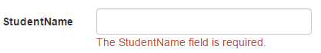

## **Custom Error Message**

You can display custom error messages instead of the default error message as above. You can provide a custom error message either in the data annotation attribute or in the ValidationMessageFor() method.

Use the ErrorMessage parameter of the data annotation attribute to provide your own custom error message, as shown below.

Example: Custom error message in the Model

**public class** Student

{

**public int** StudentId { get; set; }

[Required(ErrorMessage="Please enter student name.")]

**public string** StudentName { get; set; }

**public int** Age { get; set; }

}

You can also specify a message as a second parameter in the ValidationMessage() method, as shown below.

Example: Custom error message

@model Student

@Html.Editor("StudentName") **<br />**

@Html.ValidationMessageFor(m =**>** m.StudentName, "Please enter student name.", new { @class = "text-danger" })

It is recommended to use ValidationMessageFor() than ValidationMessage() because it is strongly typed and so performs fast and less error pron.

# ASP.NET MVC: ValidationSummary

The [ValidationSummary()](https://docs.microsoft.com/en-us/dotnet/api/system.web.mvc.html.validationextensions.validationsummary?view=aspnet-mvc-5.2" \t "_blank) extension method displays a summary of all validation errors on a web page as an unordered list element. It can also be used to display custom error messages.

The ValidationMessageFor displays an error message for an individual field, whereas the ValidationSummary displays all the error messages.

Consider the following Student model class with the Required and Range validation attributes.

Example: Student Model

**public class** Student

{

**public int** StudentId { get; set; }

[Required]

**public string** StudentName { get; set; }

[Range(10, 20)]

**public int** Age { get; set; }

}

The following view uses the ValidationSummary() method to display all the error messages.

Example: ValidationMessageFor

@model Student

@Html.ValidationSummary(false, "", new { @class = "text-danger" })

@Html.HiddenFor(model =**>** model.StudentId)

@Html.EditorFor(m =**>** m.StudentName) **<br />**

@Html.EditorFor(m =**>** m.Age) **<br />**

Above, the first parameter of the ValidationSummary() is false, so it will display the field level errors as a summary. The second parameter is for the message. We don't want to provide a message there so specify an empty string. The third parameter is for HTML attributes such as CSS class for messages. The above will display the error messages as a summary shown below.

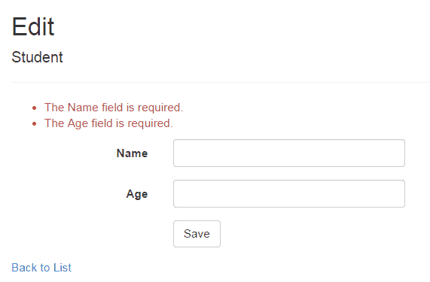

## **Display Custom Error Messages**

You can also display a custom error message using ValidationSummary.

Here, we will display a message if a student's name already exists in the database. So, in the HTTP Post action method, check the name in the database and add error message in the ModelState dictionary if the name already exists, as shown below.

Example: Edit Action methods:

**public class** StudentController : Controller

{

**public** ActionResult Edit(**int** id)

{

**var** stud = ... **get** the data **from** the DB **using** Entity Framework

**return** View(stud);

}

[HttpPost]

**public** ActionResult Edit(Student std)

{

**if** (ModelState.IsValid) { //checking model state

//check whether name is already exists in the database or not

**bool** nameAlreadyExists = \* check database \*

**if**(nameAlreadyExists)

{

//adding error message to ModelState

ModelState.AddModelError("name", "Student Name Already Exists.");

**return** View(std);

}

**return** RedirectToAction("Index");

}

**return** View(std);

}

}

Above, we added a custom error message using the ModelState.AddModelError() method. The ValidationSummary() method will automatically display all the error messages added into the ModelState.

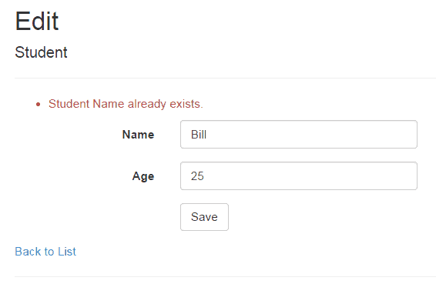

# What is Layout View in ASP.NET MVC

In this section, you will learn about the layout view in ASP.NET MVC.

An application may contain a specific UI portion that remains the same throughout the application, such as header, left navigation bar, right bar, or footer section. ASP.NET MVC introduced a Layout view which contains these common UI portions so that we don't have to write the same code in every page. The layout view is the same as the master page of the ASP.NET webform application.

For example, an application UI may contain a header, left menu bar, right bar, and footer section that remains the same on every page. Only the center section changes dynamically, as shown below.

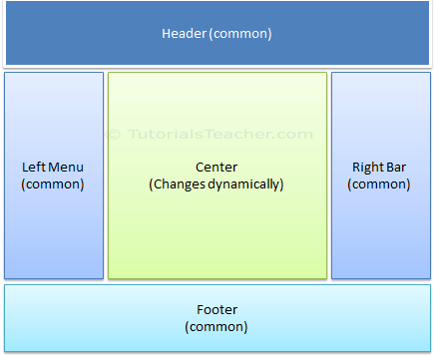 Sample Application UI Parts

The layout view allows you to define a common site template, which can be inherited in multiple views to provide a consistent look and feel in multiple pages of an application. The layout view eliminates duplicate coding and enhances development speed and easy maintenance. The layout view for the above sample UI would contain a Header, Left Menu, Right bar, and Footer sections. It has a placeholder for the center section that changes dynamically, as shown below.

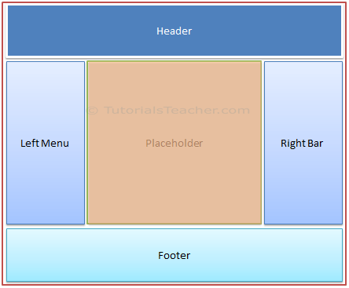 Layout View

The layout view has the same extension as other views, .cshtml or .vbhtml. Layout views are shared with multiple views, so it must be stored in the Shared folder. By default, a layout view \_Layout.cshtml is created when you Create MVC application using Visual Studio, as shown below.

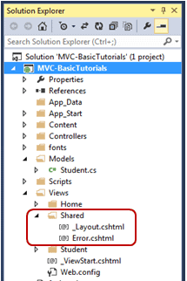 Layout Views in Shared Folder

The following is the default \_Layout.cshtml.

\_Layout.cshtml:

**<!DOCTYPE** html**>**

**<html>**

**<head>**

**<meta** **charset**="utf-8" **/>**

**<meta** **name**="viewport" **content**="width=device-width, initial-scale=1.0"**>**

**<title>**@ViewBag.Title - My ASP.NET Application**</title>**

@Styles.Render("~/Content/css")

@Scripts.Render("~/bundles/modernizr")

**</head>**

**<body>**

**<div** **class**="navbar navbar-inverse navbar-fixed-top"**>**

**<div** **class**="container"**>**

**<div** **class**="navbar-header"**>**

**<button** **type**="button" **class**="navbar-toggle"

**data-toggle**="collapse" **data-target**=".navbar-collapse"**>**

**<span** **class**="icon-bar"**></span>**

**<span** **class**="icon-bar"**></span>**

**<span** **class**="icon-bar"**></span>**

**</button>**

@Html.ActionLink("Application name", "Index", "Home",

new { area = "" }, new { @class = "navbar-brand" })

**</div>**

**<div** **class**="navbar-collapse collapse"**>**

**<ul** **class**="nav navbar-nav"**>**

**<li>**@Html.ActionLink("Home", "Index", "Home")**</li>**

**<li>**@Html.ActionLink("About", "About", "Home")**</li>**

**<li>**@Html.ActionLink("Contact", "Contact", "Home")**</li>**

**</ul>**

**</div>**

**</div>**

**</div>**

**<div** **class**="container body-content"**>**

@RenderBody()

**<hr />**

**<footer>**

**<p>**&copy; @DateTime.Now.Year - My ASP.NET Application**</p>**

**</footer>**

**</div>**

@Scripts.Render("~/bundles/jquery")

@Scripts.Render("~/bundles/bootstrap")

@RenderSection("scripts", required: false)

**</body>**

**</html>**

As you can see, the layout view contains HTML Doctype, head, and body tags. The only difference is a call to RenderBody() and RenderSection() methods. The child views will be displayed where the RenderBody() is called.

## **Using Layout View**

The views which will be displayed in a placeholder RenderBody() are called child views. There are multiple ways to specify which layout view will be used with which child views. You can specify it in a common \_ViewStart.cshtml, in a child view, or in an action method.

### **ViewStart**

The default \_ViewStart.cshtml is included in the Views folder. It can also be created in all other Views sub-folders. It is used to specify common settings for all the views under a folder and sub-folders where it is created.

Set the Layout property to a particular layout view will be applicable to all the child views under that folder and its sub-folders.

For example, the following \_ViewStart.cshtml in the **Views** folder sets the Layout property to "~/Views/Shared/\_Layout.cshtml". So, the \_layout.cshtml would be a layout view of all the views included in Views and its subfolders.

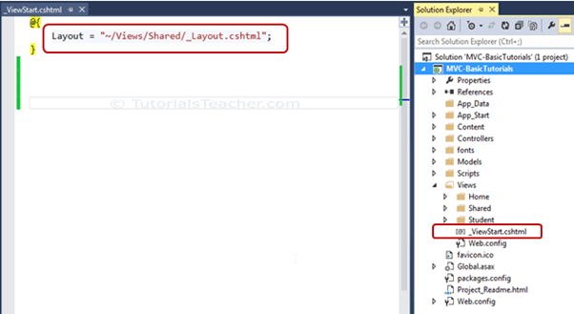Setting Layout View in \_ViewStart.cshtml

The \_ViewStart.cshtml can also be created in the sub-folders of the View folder to set the default layout page for all the views included in that particular subfolder.

For example, the following \_ViewStart.cshtml in the Home folder sets the Layout property to \_myLayoutPage.cshtml. So now, Index.cshtml, About.cshtml and Contact.cshtml will display in the \_myLayoutPage.cshtml instead of default \_Layout.cshml.

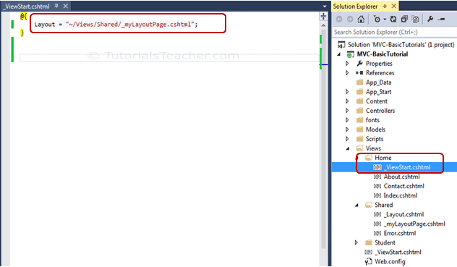Layout View in Sub-folders

## **Specify Layout View in a Child View**

You can also override the default layout view setting of \_ViewStart.cshtml by setting the Layout property in each child view. For example, the following Index.cshtml view uses the \_myLayoutPage.cshtml even if \_ViewStart.cshtml sets the \_Layout.cshtml.

Index.cshtml

@{

ViewBag.Title = "Home Page";

Layout = "~/Views/Shared/\_myLayoutPage.cshtml";

}

**<div** **class**="jumbotron"**>**

**<h1>**ASP.NET**</h1>**

**<p** **class**="lead"**>**ASP.NET is a free web framework for building great Web sites and Web applications using HTML, CSS and JavaScript.**</p>**

**<p><a** **href**="http://asp.net" **class**="btn btn-primary btn-lg"**>**Learn more &raquo;**</a></p>**

**</div>**

**<div** **class**="row"**>**

**<div** **class**="col-md-4"**>**

**<h2>**Getting started**</h2>**

**<p>**

ASP.NET MVC gives you a powerful, patterns-based way to build dynamic websites that

enables a clean separation of concerns and gives you full control over markup

for enjoyable, agile development.

**</p>**

**<p><a** **class**="btn btn-default" **href**="http://go.microsoft.com/fwlink/?LinkId=301865"**>**Learn more &raquo;**</a></p>**

**</div>**

**<div** **class**="col-md-4"**>**

**<h2>**Get more libraries**</h2>**

**<p>**NuGet is a free Visual Studio extension that makes it easy to add, remove, and update libraries and tools in Visual Studio projects.**</p>**

**<p><a** **class**="btn btn-default" **href**="http://go.microsoft.com/fwlink/?LinkId=301866"**>**Learn more &raquo;**</a></p>**

**</div>**

**<div** **class**="col-md-4"**>**

**<h2>**Web Hosting**</h2>**

**<p>**You can easily find a web hosting company that offers the right mix of features and price for your applications.**</p>**

**<p><a** **class**="btn btn-default" **href**="http://go.microsoft.com/fwlink/?LinkId=301867"**>**Learn more &raquo;**</a></p>**

**</div>**

**</div>**

## **Specify Layout Page in Action Method**

Specify the layout view name as a second parameter in the View() method, as shown below. By default, layout view will be searched in the Shared folder.

Example: Specify Layout View in Action Method

**public class** HomeController : Controller

{

**public** ActionResult Index()

{

**return** View("Index","\_myLayoutPage");//set "\_myLayoutView" as layout view

}

}

## **Rendering Methods**

ASP.NET MVC layout view renders child views using the following methods.

| Method | Description |
| --- | --- |
| RenderBody() | Renders the portion of the child view that is not within a named section. Layout view must include the RenderBody() method. |
| RenderSection(string name) | Renders a content of named section and specifies whether the section is required. |

The following figure illustrates the use of the RenderBody() and RenderSection() methods.

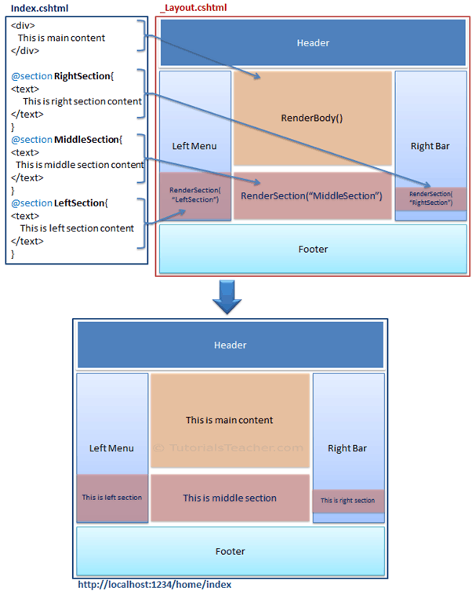 Rendering Methods

As you can see in the above figure, the \_Layout.cshtml includes the RenderBody() method and RenderSection() method. Above, Index.cshtml contains the named sections using @section where the name of each section matches the name specified in the RenderSection() method of a layout view \_Layout.cshtml, e.g. @Section RightSection. At run time, the named sections of Index.cshtml, such as LeftSection, RightSection, and MiddleSection will be rendered at appropriate place where the RenderSection() method is called. The rest of the Index.cshtml view, which is not in any of the named section, will be rendered in the RenderBody() is called.

Let's create a new layout view to understand the above render methods in the next section.

# Create a Layout View

You learned what is the layout view in ASP.NET MVC. Here you will learn how to create a layout view using Visual Studio.

You can create a layout view in any folder under the Views folder. However, it is recommended to create all the layout views in the Shared folder for easy maintenance purpose.

To create a new layout view in Visual Studio, right-click on the Shared folder -> select Add -> click on **New Item..**. This will open the **Add New Item** popup, as shown below.

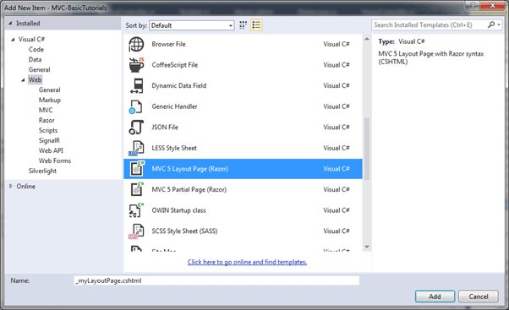Create Layout View

In the **Add New Item** dialogue box, select MVC 5 Layout Page (Razor) template, and specify a layout view name as \_myLayoutPage.cshtml and click **Add** to create it as shown below. Prefixing the underscore \_ before layout view name is a common naming convention in ASP.NET MVC.

\_

myLayoutPage.cshtml

**<!DOCTYPE** html**>**

**<html>**

**<head>**

**<meta** **name**="viewport" **content**="width=device-width" **/>**

**<title>**@ViewBag.Title**</title>**

**</head>**

**<body>**

**<div>**

@RenderBody()

**</div>**

**</body>**

**</html>**

Now, let's add the common <footer> tag with the RenderSection("footer",true) method, as shown below. Please notice that we made this section as required. It means any view that uses the \_myLayoutPage as its layout view must include a footer section.

Example: Adding RenderSection

**<!DOCTYPE** html**>**

**<html>**

**<head>**

**<meta** **name**="viewport" **content**="width=device-width" **/>**

**<title>**@ViewBag.Title**</title>**

@Styles.Render("~/Content/css")

@Scripts.Render("~/bundles/modernizr")

**</head>**

**<body>**

**<div>**

@RenderBody()

**</div>**

**<footer** **class**="panel-footer"**>**

@RenderSection("footer", true)

**</footer>**

**</body>**

**</html>**

Now, create a new child view and select \_myLayoutPage.cshtml as a layout view, as shown below.

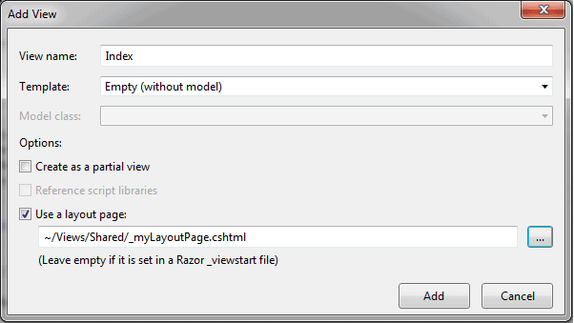

This will create a new Index.cshtml as shown below.

Index.cshtml

@{

ViewBag.Title = "Home Page";

Layout = "~/Views/Shared/\_myLayoutPage.cshtml";

}

**<h2>**Index**</h2>**

Now, add the footer section because \_myLayoutPage.cshtml contains the mandatory footer section, as shown below.

Index.cshtml

@{

ViewBag.Title = "Home Page";

Layout = "~/Views/Shared/\_myLayoutPage.cshtml";

}

**<h2>**Index**</h2>**

**<div** **class**="row"**>**

**<div** **class**="col-md-4"**>**

**<p>**This is body.**</p>**

**</div>**

@section footer{

**<p** **class**="lead"**>**

This is footer section.

**</p>**

}

**</div>**

Now, run the application, and you will see that the Index view will be displayed in the RenderBody() method, and the footer section will be displayed in the RenderSection("footer", true), as shown below.

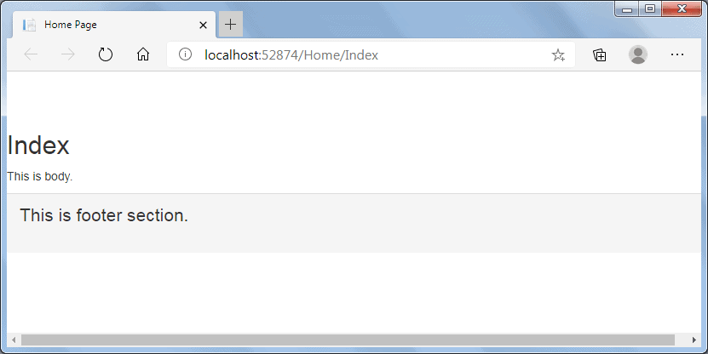

Thus, you can create a new layout view with a body and different sections.

# Create and Render Partial Views

Here you will learn what is a partial view and how to use it in the ASP.NET MVC application.

A partial view is a reusable portion of a web page. It is .cshtml or .vbhtml file that contains HTML code. It can be used in one or more Views or Layout Views. You can use the same partial view at multiple places and eliminates the redundant code.

Let's create a partial view for the following menu, so that we can use the same menu in multiple layout views without rewriting the same code everywhere.

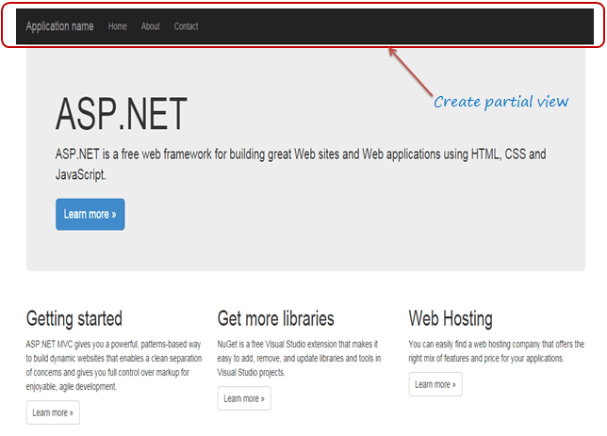Partial View

We created our first MVC application before. Open \_Layout.cshtml file, and you will see the following HTML code for the above menu bar. We will cut and paste this code in a separate partial view.

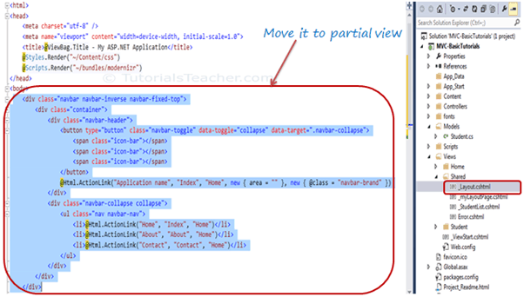

Partial Views

## **Create a New Partial View**

To create a partial view, right click on the Shared folder -> click **Add**-> click **View..** to open the Add View popup, as shown below.

You can create a partial view in any View folder. However, it is recommended to create all your partial views in the Shared folder so that they can be used in multiple views.

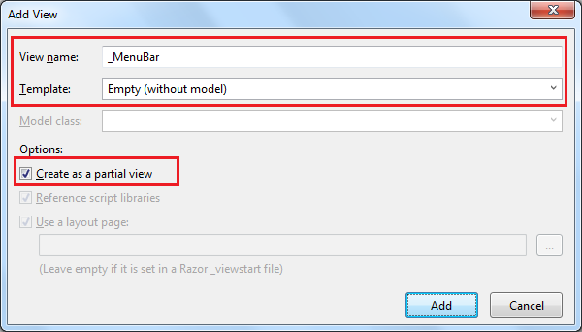

Add Partial View

In the Add New Item popup, enter a partial view name, select "Create as a partial view" checkbox. We don't need not use any model for this partial view, so keep the Template dropdown as Empty (without model) and click on **Add** button. This will create an empty partial view in the Shared folder.

You can now cut the above code for the navigation bar and paste it in \_MenuBar.cshtml as shown below:

\_MenuBar.cshtml

**<div** **class**="navbar navbar-inverse navbar-fixed-top"**>**

**<div** **class**="container"**>**

**<div** **class**="navbar-header"**>**

**<button** **type**="button" **class**="navbar-toggle"

**data-toggle**="collapse" **data-target**=".navbar-collapse"**>**

**<span** **class**="icon-bar"**></span>**

**<span** **class**="icon-bar"**></span>**

**<span** **class**="icon-bar"**></span>**

**</button>**

@Html.ActionLink("Application name", "Index", "Home",

new { area = "" }, new { @class = "navbar-brand" })

**</div>**

**<div** **class**="navbar-collapse collapse"**>**

**<ul** **class**="nav navbar-nav"**>**

**<li>**@Html.ActionLink("Home", "Index", "Home")**</li>**

**<li>**@Html.ActionLink("About", "About", "Home")**</li>**

**<li>**@Html.ActionLink("Contact", "Contact", "Home")**</li>**

**</ul>**

**</div>**

**</div>**

**</div>**

Thus, you can create a new partial view. Let's see how to render partial view.

## **Rendering a Partial View**

You can render the partial view in the parent view using the HTML helper methods: @html.Partial(), @html.RenderPartial(), and @html.RenderAction().

## **Html.Partial()**

The @Html.Partial() method renders the specified partial view. It accepts partial view name as a string parameter and returns MvcHtmlString. It returns an HTML string, so you have a chance of modifying the HTML before rendering.

Visit docs.microsoft.com to know the [overloads of the Partial()](https://docs.microsoft.com/en-us/dotnet/api/system.web.mvc.html.partialextensions.partial?view=aspnet-mvc-5.2#overloads) method.

Now, include \_MenuBar partial view in\_Layout.cshtml using @html.Partial("\_MenuBar"), as shown below.

\_MenuBar

**<!DOCTYPE** html**>**

**<html>**

**<head>**

**<meta** **charset**="utf-8" **/>**

**<meta** **name**="viewport" **content**="width=device-width, initial-scale=1.0"**>**

**<title>**@ViewBag.Title - My ASP.NET Application**</title>**

@Styles.Render("~/Content/css")

@Scripts.Render("~/bundles/modernizr")

**</head>**

**<body>**

@Html.Partial("\_MenuBar")

@\* you can modify result as below \*@

@\* var result = Html.Partial("\_MenuBar") \*@

**<div** **class**="container body-content"**>**

@RenderBody()

**<hr />**

**<footer>**

**<p>**&copy; @DateTime.Now.Year - My ASP.NET Application**</p>**

**</footer>**

**</div>**

@Scripts.Render("~/bundles/jquery")

@Scripts.Render("~/bundles/bootstrap")

@RenderSection("scripts", required: false)

**</body>**

**</html>**

## **Html.RenderPartial()**

The @html.RenderPartial() method is the same as the @html.Partial() method except that it writes the resulted HTML of a specified partial view into an HTTP response stream directly. So, you can modify it's HTML before render.

Visit docs.microsoft.com to know the [overloads of the RenderPartial()](https://docs.microsoft.com/en-us/dotnet/api/system.web.mvc.html.renderpartialextensions?view=aspnet-mvc-5.2#methods) method.

Example: Html.RenderPartial()

**<!DOCTYPE** html**>**

**<html>**

**<head>**

**<meta** **charset**="utf-8" **/>**

**<meta** **name**="viewport" **content**="width=device-width, initial-scale=1.0"**>**

**<title>**@ViewBag.Title - My ASP.NET Application**</title>**

@Styles.Render("~/Content/css")

@Scripts.Render("~/bundles/modernizr")

**</head>**

**<body>**

@{

Html.RenderPartial("\_MenuBar");

}

**<div** **class**="container body-content"**>**

@RenderBody()

**<hr />**

**<footer>**

**<p>**&copy; @DateTime.Now.Year - My ASP.NET Application**</p>**

**</footer>**

**</div>**

@Scripts.Render("~/bundles/jquery")

@Scripts.Render("~/bundles/bootstrap")

@RenderSection("scripts", required: false)

**</body>**

**</html>**

The RenderPartial() method returns void, so a semicolon is required at the end, and so it must be enclosed within the @{ }.

## **Html.RenderAction()**

The @html.RenderAction() method executes the specified action method and renders the result. The specified action method must be marked with the [ChildActionOnly] attribute and return the PartialViewResult using the PartialView() method.

Visit docs.microsoft.com to know the [overloads of the RenderAction()](https://docs.microsoft.com/en-us/dotnet/api/system.web.mvc.html.childactionextensions.renderaction?view=aspnet-mvc-5.2#overloads) method.

To render a partial view using the RenderAction() method, first create an HttpGet action method and apply the ChildActionOnly attribute as shown below.

Example: Action Method Parameters

**public class** HomeController : Controller

{

[ChildActionOnly]

**public** ActionResult RenderMenu()

{

**return** PartialView("\_MenuBar");

}

}

Now, call the html.RenderAction("RenderMenu", "Home") in the layout view, as shown below.

Example: Html.RenderPartial()

**<!DOCTYPE** html**>**

**<html>**

**<head>**

**<meta** **charset**="utf-8" **/>**

**<meta** **name**="viewport" **content**="width=device-width, initial-scale=1.0"**>**

**<title>**@ViewBag.Title - My ASP.NET Application**</title>**

@Styles.Render("~/Content/css")

@Scripts.Render("~/bundles/modernizr")

**</head>**

**<body>**

@{

Html.RenderAction("RenderMenu", "Home");

}

**<div** **class**="container body-content"**>**

@RenderBody()

**<hr />**

**<footer>**

**<p>**&copy; @DateTime.Now.Year - My ASP.NET Application**</p>**

**</footer>**

**</div>**

@Scripts.Render("~/bundles/jquery")

@Scripts.Render("~/bundles/bootstrap")

@RenderSection("scripts", required: false)

**</body>**

**</html>**

You will see the following result in the browser, irrespective of the rendering method you use.

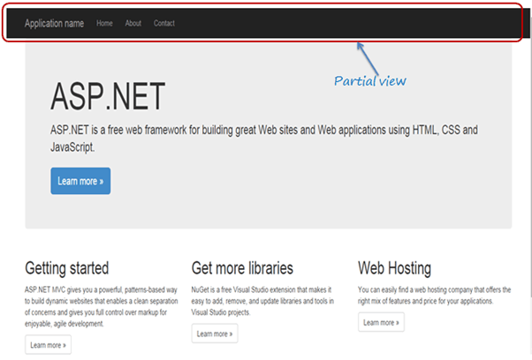

In this way, you can create a partial view for different portions of the web page in ASP.NET MVC application.

# ASP.NET MVC - ViewBag

The ViewBag in ASP.NET MVC is used to transfer temporary data (which is not included in the model) from the controller to the view.

Internally, it is a dynamic type property of the ControllerBase class which is the base class of the Controller class.

The following figure illustrates the ViewBag.

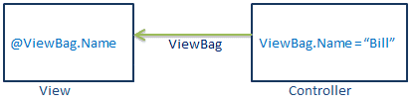 ViewBag Data Transfer

In the above figure, it attaches Name property to ViewBag with the dot notation and assigns a string value "Bill" to it in the controller. This can be accessed in the view like @ViewBag.Name.

You can assign a primitive or a complex type object as a value to ViewBag property.

You can assign any number of properties and values to ViewBag. If you assign the same property name multiple times to ViewBag, then it will only consider last value assigned to the property.

 Note:

ViewBag only transfers data from controller to view, not visa-versa. ViewBag values will be null if redirection occurs.

The following example demonstrates how to transfer data from controller to view using ViewBag.

Example: Set ViewBag in Action method

**namespace** MVC\_BasicTutorials.Controllers

{

**public class** StudentController : Controller

{

IList<Student> studentList = **new** List<Student>() {

**new** Student(){ StudentID=1, StudentName="Steve", Age = 21 },

**new** Student(){ StudentID=2, StudentName="Bill", Age = 25 },

**new** Student(){ StudentID=3, StudentName="Ram", Age = 20 },

**new** Student(){ StudentID=4, StudentName="Ron", Age = 31 },

**new** Student(){ StudentID=5, StudentName="Rob", Age = 19 }

};

// GET: Student

**public** ActionResult Index()

{

ViewBag.TotalStudents = studentList.Count();

**return** View();

}

}

}

In the above example, we want to display the total number of students in a view. So, we have attached the TotalStudents property to the ViewBag and assigned studentList.Count() value.

Now, in the Index.cshtml view, you can access ViewBag.TotalStudents property, as shown below.

Index.cshtml

**<label>**Total Students:**</label>** @ViewBag.TotalStudents

Output:

Total Students: 5

Internally, ViewBag is a wrapper around ViewData. It will throw a runtime exception, if the ViewBag property name matches with the key of ViewData.

## **ViewBag Limitations**

* ViewBag doesn't require typecasting while retrieving values from it. This can throw a run-time exception if the wrong method is used on the value.
* ViewBag is a dynamic type and skips compile-time checking. So, ViewBag property names must match in controller and view while writing it manually.

ASP.NET MVC - ViewData

In ASP.NET MVC, ViewData is similar to ViewBag, which transfers data from Controller to View. ViewData is of Dictionary type, whereas ViewBag is of dynamic type. However, both store data in the same dictionary internally.

ViewData is a dictionary, so it contains key-value pairs where each key must be a string.

The following figure illustrates the ViewData.

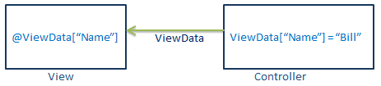

 Note:

ViewData only transfers data from controller to view, not vice-versa. It is valid only during the current request.

The following example demonstrates how to transfer data from controller to view using ViewData.

Example: ViewData in Action method

**public** ActionResult Index()

{

IList<Student> studentList = **new** List<Student>();

studentList.Add(**new** Student(){ StudentName = "Bill" });

studentList.Add(**new** Student(){ StudentName = "Steve" });

studentList.Add(**new** Student(){ StudentName = "Ram" });

ViewData["students"] = studentList;

**return** View();

}

In the above example, ViewData["students"] assigned to a studentList where "students" is a key and studentList is a value. You can now access ViewData["students"] in the view, as shown below.

Example: Access ViewData in a Razor View

**<ul>**

@**foreach** (**var** std **in** ViewData["students"] **as** IList<Student>)

{

**<li>**@std.StudentName**</li>**

}

**</ul>**

Above, we retrieve the value using ViewData["students"] and typecast it to an appropriate data type. You can also add KeyValuePair objects into the ViewData, as shown below.

Example: Add KeyValuePair in ViewData

**public** ActionResult Index()

{

ViewData.Add("Id", 1);

ViewData.Add(**new** KeyValuePair<**string**, **object**>("Name", "Bill"));

ViewData.Add(**new** KeyValuePair<**string**, **object**>("Age", 20));

**return** View();

}

ViewData and ViewBag both use the same dictionary internally. So you cannot have ViewData Key matches with the property name of ViewBag, otherwise it will throw a runtime exception.

Example: ViewBag and ViewData

**public** ActionResult Index()

{

ViewBag.Id = 1;

ViewData.Add("Id", 1);// throw runtime exception as it already has "Id" key

ViewData.Add(**new** KeyValuePair<**string**, **object**>("Name", "Bill"));

ViewData.Add(**new** KeyValuePair<**string**, **object**>("Age", 20));

**return** View();

}

 Points to Remember :

1. ViewData transfers data from the Controller to View, not vice-versa.
2. ViewData is a dictionary type.
3. ViewData's life only lasts during the current HTTP request. ViewData values will be cleared if redirection occurs.
4. ViewData value must be typecast to an appropriate type before using it.
5. ViewBag internally inserts data into ViewData dictionary. So the key of ViewData and property of ViewBag must **NOT** match.

# ASP.NET MVC - TempData

TempData is used to transfer data from view to controller, controller to view, or from one action method to another action method of the same or a different controller.

TempData stores the data temporarily and automatically removes it after retrieving a value.

TempData is a property in the [ControllerBase](https://docs.microsoft.com/en-us/dotnet/api/system.web.mvc.controllerbase?view=aspnet-mvc-5.2" \l "properties" \t "_blank) class. So, it is available in any controller or view in the ASP.NET MVC application.

The following example shows how to transfer data from one action method to another using TempData.

Example: TempData

**public class** HomeController : Controller

{

**public** ActionResult Index()

{

TempData["name"] = "Bill";

**return** View();

}

**public** ActionResult About()

{

**string** name;

**if**(TempData.ContainsKey("name"))

name = TempData["name"].ToString(); // returns "Bill"

**return** View();

}

**public** ActionResult Contact()

{

//the following throws exception as TempData["name"] is null

//because we already accessed it in the About() action method

//name = TempData["name"].ToString();

**return** View();

}

}

In the above example, we added data in the TempData in the Index() action method and access it in the About() action method. Assume that the user will go to the Index page first and then to the About page.

The following transfers data from an action method to a view.

Example: TempData

**public class** HomeController : Controller

{

**public** ActionResult Index()

{

TempData["name"] = "Bill";

**return** View();

}

**public** ActionResult About()

{

//the following throws exception as TempData["name"] is null

//because we already accessed it in the Index.cshtml view

//name = TempData["name"].ToString();

**return** View();

}

**public** ActionResult Contact()

{

//the following throws exception as TempData["name"] is null

//because we already accessed it in the Index.cshtml view

//name = TempData["name"].ToString();

**return** View();

}

}

Above, we added data in the TempData in the Index() action method. So, we can access it in the Index.cshtml view, as shown below. Because we have accessed it in the index view first, we cannot access it anywhere else.

Index.cshtml

@{

ViewBag.Title = "Index";

Layout = "~/Views/Shared/\_Layout.cshtml";

}

@TempData["name"]

You can also transfer data from a view to controller, as shown below.

Index.cshtml

@{

ViewBag.Title = "Index";

Layout = "~/Views/Shared/\_Layout.cshtml";

}

@{

TempData["name"] = "Steve";

}

The above TempData can be accessed in the controller, as shown below.

Example: TempData

**public class** HomeController : Controller

{

**public** ActionResult Index()

{

**return** View();

**public** ActionResult About()

{

**if**(TempData.ContainsKey("name"))

name = TempData["name"].ToString(); // returns "Bill"

**return** View();

}

**public** ActionResult Contact()

{

//the following throws exception as TempData["name"] is null

//because we already accessed it in the About() action method

//name = TempData["name"].ToString();

**return** View();

}

}

Although, TempData removes a key-value once accessed, you can still keep it for the subsequent request by calling TempData.Keep() method.

The following example shows how to retain TempData value for the subsequent requests even after accessing it.

Example: TempData.Keep()

**public class** HomeController : Controller

{

**public** ActionResult Index()

{

TempData["name"] = "Bill";

**return** View();

}

**public** ActionResult About()

{

**string** name;

**if**(TempData.ContainsKey("name")) name = TempData["name"] **as string**;

TempData.Keep("name");//Marks specified key for TempData retention.

//TempData.Keep(); // Marks all keys in the TempData for retention

**return** View();

}

**public** ActionResult Contact()

{

**string** name;

**if**(TempData.ContainsKey("name")) data = TempData["name"] **as string**;

**return** View();

}

}

# ASP.NET MVC- Filters

In ASP.NET MVC, a user request is routed to the appropriate controller and action method. However, there may be circumstances where you want to execute some logic before or after an action method executes. ASP.NET MVC provides filters for this purpose.

ASP.NET MVC Filter is a custom class where you can write custom logic to execute before or after an action method executes. Filters can be applied to an action method or controller in a declarative or programmatic way. Declarative means by applying a filter attribute to an action method or controller class and programmatic means by implementing a corresponding interface.

MVC provides different types of filters. The following table list filter types, built-in filters, and interface that must be implemented to create custom filters.

| **Filter Type** | **Description** | **Built-in Filter** | **Interface** |
| --- | --- | --- | --- |
| Authorization filters | Performs authentication and authorizes before executing an action method. | [Authorize], [RequireHttps] | IAuthorizationFilter |
| Action filters | Performs some operation before and after an action method executes. |  | IActionFilter |
| Result filters | Performs some operation before or after the execution of the view. | [OutputCache] | IResultFilter |
| Exception filters | Performs some operation if there is an unhandled exception thrown during the execution of the ASP.NET MVC pipeline. | [HandleError] | IExceptionFilter |

To understand the filter in detail, let's take an example of a built-in Exception filter. Exception filter executes when an unhandled exception occurs in your application. The HandleErrorAttribute class is a built-in exception filter class that renders the Error.cshtml by default when an unhandled exception occurs.

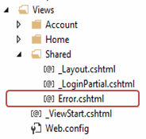

The following example demonstrates the use of [HandError] attribute on the controller class.

Example: Exception Filter

[HandleError]

**public class** HomeController : Controller

{

**public** ActionResult Index()

{

//throw exception for demo

**throw new** Exception("This is unhandled exception");

**return** View();

}

**public** ActionResult About()

{

**return** View();

}

**public** ActionResult Contact()

{

**return** View();

}

}

Above, the [HandleError] attribute applied to the HomeController. So, an error page Error.cshtml will be displayed if any action method of the HomeController throws an unhandled exception. Please note that unhandled exceptions are exceptions that are not handled by the try-catch blocks.

Filters applied to the controller will automatically be applied to all the action methods of a controller.

Please make sure that the CustomError mode is on in System.web section of web.config.

Example: Set CustomError Mode in web.config

**<customErrors** **mode**="On" **/>**

Now, if you run the application, you would get the following error page because we throw an exception in the Index() action method for the demo purpose.

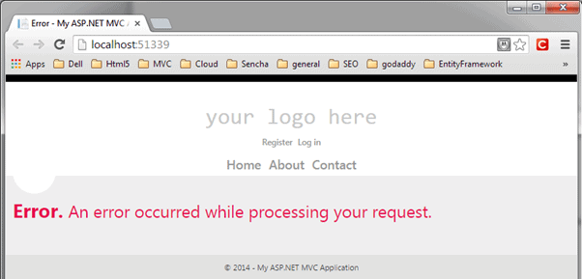

## **Register Filters**

Filters can be applied at three levels.

### **Global Level Filters**

You can apply filters at a global level in the Application\_Start event of the global.asax.cs file by using default FilterConfig.RegisterGlobalFilters() method. The global filters will be applied to all the controller and action methods of an application.

The [HandleError] filter is applied globally in the MVC application by default in every MVC application created using Visual Studio, as shown below.

Example: Register Global Filters

// MvcApplication class contains in Global.asax.cs file

**public class** MvcApplication : System.Web.HttpApplication

{

**protected void** Application\_Start()

{

FilterConfig.RegisterGlobalFilters(GlobalFilters.Filters);

}

}

// FilterConfig.cs located in App\_Start folder

**public class** FilterConfig

{

**public static void** RegisterGlobalFilters(GlobalFilterCollection filters)

{

filters.Add(**new** HandleErrorAttribute());

}

}

### **Controller Level Filters**

Filters can also be applied to the controller class. Controller level filters are applied to all the action methods. The following filter are applicable to all the action methods of the HomeController, but not on other controllers.

Example: Action Filters on Controller

[HandleError]

**public class** HomeController : Controller

{

**public** ActionResult Index()

{

**return** View();

}

**public** ActionResult About()

{

**return** View();

}

**public** ActionResult Contact()

{

**return** View();

}

}

### **Action Method Filters**

One or more filters can also applied to an individual action method. The following filter applied only on the Index() action method.

Example: Filters on Action Method

**public class** HomeController : Controller

{

[HandleError]

**public** ActionResult Index()

{

**return** View();

}

**public** ActionResult About()

{

**return** View();

}

**public** ActionResult Contact()

{

**return** View();

}

}

# ASP.NET MVC - Action Filters

In the previous section, you learned about filters in MVC. In this section, you will learn about another filter type called action filters in ASP.NET MVC.

Action filter executes before and after an action method executes. Action filter attributes can be applied to an individual action method or to a controller. When an action filter is applied to a controller, it will be applied to all the controller's action methods.

The OutputCache is a built-in action filter attribute that can be applied to an action method for which we want to cache the output. For example, the output of the following action method will be cached for 100 seconds.

Example: ActionFilter

[OutputCache(Duration=100)]

**public** ActionResult Index()

{

**return** View();

}

## **Crete a Custom Action Filter**

You can create a custom action filter in two ways, first, by implementing the IActionFilter interface and the FilterAttribute class. Second, by deriving the ActionFilterAttribute abstract class.

The [IActionFilter](https://docs.microsoft.com/en-us/dotnet/api/system.web.mvc.iactionfilter?view=aspnet-mvc-5.2" \t "_blank) interface include following methods to implement:

* void OnActionExecuted(ActionExecutedContext filterContext)
* void OnActionExecuting(ActionExecutingContext filterContext)

The [ActionFilterAttribute](https://docs.microsoft.com/en-us/dotnet/api/system.web.mvc.actionfilterattribute?view=aspnet-mvc-5.2" \t "_blank) abstract class includes the following methods to override:

* void OnActionExecuted(ActionExecutedContext filterContext)
* void OnActionExecuting(ActionExecutingContext filterContext)
* void OnResultExecuted(ResultExecutedContext filterContext)
* void OnResultExecuting(ResultExecutingContext filterContext)

As you can see, the ActionFilterAttribute class has four overload methods. It includes the OnResultExecuted and the OnResultExecuting methods, which can be used to execute custom logic before or after the result executes. Action filters are generally used to apply cross-cutting concerns such as logging, caching, authorization, etc.

The following example demonstrates creating a custom action filter class for logging.

Example: Custom ActionFilter for Logging

**public class** LogAttribute : ActionFilterAttribute

{

**public override void** OnActionExecuted(ActionExecutedContext filterContext)

{

Log("OnActionExecuted", filterContext.RouteData);

}

**public override void** OnActionExecuting(

ActionExecutingContext filterContext)

{

Log("OnActionExecuting", filterContext.RouteData);

}

**public override void** OnResultExecuted(ResultExecutedContext filterContext)

{

Log("OnResultExecuted", filterContext.RouteData);

}

**public override void** OnResultExecuting(

ResultExecutingContext filterContext)

{

Log("OnResultExecuting ", filterContext.RouteData);

}

**private void** Log(**string** methodName, RouteData routeData)

{

**var** controllerName = routeData.Values["controller"];

**var** actionName = routeData.Values["action"];

**var** message = String.Format("{0}- controller:{1} action:{2}",

methodName, controllerName, actionName);

Debug.WriteLine(message);

}

}

Above, the Log class derived the ActionFilterAttribute class. It logs before and after the action method or result executes. You can apply the Log attribute to any controller or an action method where you want to log the execution of the action method.

Example: ActionFilter on Controller

[Log]

**public class** HomeController : Controller

{

**public** ActionResult Index()

{

**return** View();

}

**public** ActionResult About()

{

**return** View();

}

**public** ActionResult Contact()

{

**return** View();

}

}

The above example will show the following output when browsing to *http://localhost/home* request.

Output:

OnActionExecuting- controller:Home action:Index  
OnActionExecuted- controller:Home action:Index  
OnResultExecuting - controller:Home action:Index  
OnResultExecuted- controller:Home action:Index

In this way, you can keep track of the action methods execution using action filters.

# Bundling and Minification

Bundling and minification techniques were introduced in MVC 4 to improve request load time. Bundling allows us to load the bunch of static files from the server in a single HTTP request.

The following figure illustrates the bundling technique:

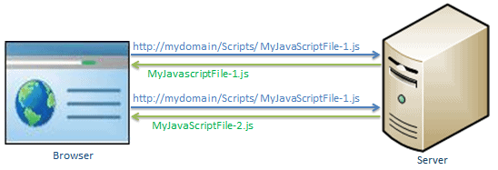

Loading script files in separate requests

In the above figure, the browser sends two separate requests to load two different JavaScript file MyJavaScriptFile-1.js and MyJavaScriptFile-2.js.

The bundling technique in ASP.NET MVC allows us to load more than one JavaScript file, MyJavaScriptFile-1.js and MyJavaScriptFile-2.js in one request, as shown below.

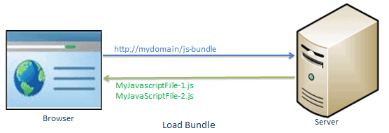

## **Minification**

Minification technique optimizes script or CSS file size by removing unnecessary white space and comments and shortening variable names to one character.

For example, consider the following JavaScript function.

Example: JavaScript

sayHello = **function**(name){

//this is comment

**var** msg = "Hello" + name;

alert(msg);

}

Minification will remove the unnecessary white spaces, comments, and shortening variable names to reduce the characters, which will reduce the size of the JavaScript file. The above JavaScript will be minimized as the following script.

Example: Minified JavaScript

sayHello=**function**(n){**var** t="Hello"+n;alert(t)}

Bundling and minification impact on the loading time of the page.

## **Bundle Types**

MVC 5 includes following bundle classes in System.web.Optimization namespace:

**ScriptBundle**: ScriptBundle is responsible for JavaScript minification of single or multiple script files.

**StyleBundle**: StyleBundle is responsible for CSS minification of single or multiple style sheet files.

**DynamicFolderBundle**: Represents a Bundle object that ASP.NET creates from a folder that contains files of the same type.

Learn about ScriptBundle in the next section.

# Combine Script Files using ScriptBundle in ASP.NET MVC

Here, you will learn how to combine multiple JavaScript files and create a script bundle that can be returned in a single HTTP request in ASP.NET MVC.

The [ScriptBundle](https://docs.microsoft.com/en-us/previous-versions/aspnet/jj646584(v=vs.110)" \t "_blank) class represents a bundle that does JavaScript minification and bundling. You can create style or script bundles in BundleConfig class under App\_Start folder in an ASP.NET MVC project. (you can create your own custom class instead of using BundleConfig class, but it is recommended to follow standard practice.)

The following example demonstrates how to create a script bundle.

Example: Create Script Bundle

**using** System.Web;

**using** System.Web.Optimization;

**public class** BundleConfig

{

**public static void** RegisterBundles(BundleCollection bundles)

{

bundles.Add(**new** ScriptBundle("~/bundles/bs-jq-bundle").Include(

"~/Scripts/bootstrap.js",

"~/Scripts/jquery-3.3.1.js"));

//the following creates bundles in debug mode;

//BundleTable.EnableOptimizations = true;

}

}

In the above example, we created a new bundle by creating an instance of the ScriptBundle class and specified the virtual path and bundle name in the constructor. The ~/bundles/ is a virtual path and bs-jq-bundle is a bundle name. Then, we added two js files, bootstrap.js, and jquery-3.3.1.js in this bundle. The bundles.Add() method is used to add new bundles into the BundleCollection. By default, the above bs-jq-bundle bundle will be created in the release mode. Use BundleTable.EnableOptimizations = true if you want to see bundles in the debug mode.

Now, to include the above bs-jq-bundle in your webpage, use Scripts.Render() method in the layout view, as shown below.

Example: Use Script Bundle

**<!DOCTYPE** html**>**

**<html>**

**<head>**

**<meta** **charset**="utf-8" **/>**

**<meta** **name**="viewport" **content**="width=device-width, initial-scale=1.0"**>**

**<title>**@ViewBag.Title**</title>**

@Scripts.Render("~/bundles/bootstrap")

**</head>**

**<body>**

@\*html code removed for clarity \*@

**</body>**

**</html>**

Now, when you run the application in the release mode, you will see the bundle is created and loaded in a single request.

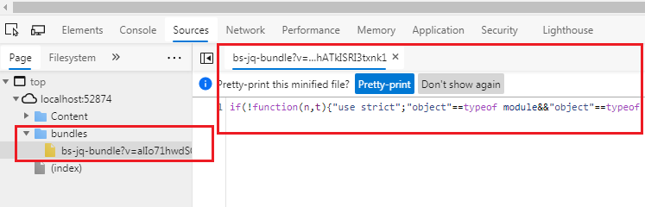

## **Include a Directory in Bundle**

Use the IncludeDirectory method to add all the files under a particular directory in a bundle, as shown below.

ScriptBundle Example:

**public static void** RegisterBundles(BundleCollection bundles)

{

bundles.Add(**new** ScriptBundle("~/bundles/scripts")

.IncludeDirectory("~/Scripts/","\*.js", **true**));

}

## **Using Wildcards**

Most third party JavaScript files include a version in the name of the script file. For example, jQuery includes the version in the file name. The wildcard {version} will automatically pick up an available version file.

Example: Wildcard with bundle

**public class** BundleConfig

{

**public static void** RegisterBundles(BundleCollection bundles)

{

bundles.Add(**new** ScriptBundle("~/bundles/jquery")

.Include( "~/Scripts/jquery-{version}.js"));

}

}

## **Using CDN**

You can also create a bundle of the files from the Content Delivery Network (CDN), as shown below.

Example: Load files from CDN

**public class** BundleConfig

{

**public static void** RegisterBundles(BundleCollection bundles)

{

**var** cdnPath =

"http://ajax.aspnetcdn.com/ajax/jQuery/jquery-1.7.1.min.js";

bundles.Add(**new** ScriptBundle("~/bundles/jquery", cdnPath)

.Include( "~/Scripts/jquery-{version}.js"));

}

}

 Note:

ASP.NET MVC framework calls the BundleConfig.RegisterBundle() from the Application\_Start event in the Global.asax.cs file. So, all the bundles are added into the BundleCollection at the starting of an application.

# StyleBundle - Combine CSS Files in ASP.NET MVC

Here you will learn how to combine multiple CSS (Cascading Style Sheet) files to return it in a single HTTP request.

ASP.NET MVC API includes [StyleBundle](https://docs.microsoft.com/en-us/previous-versions/aspnet/jj646585(v=vs.110)" \t "_blank) class that does CSS minification and bundling. Same as the script bundle, all the style bundles should be created in the BundleConfig class. under the App\_Start folder.

The following example shows how to combine multiple CSS files into a bundle.

Example: Create Style Bundle

**public class** BundleConfig

{

**public static void** RegisterBundles(BundleCollection bundles)

{

bundles.Add(**new** StyleBundle("~/bundles/css").Include(

"~/Content/bootstrap.css",

"~/Content/site.css"

));

// add ScriptBundle here..

}

}

In the above example, we created a new style bundle by creating an instance of the StyleBundle class and specified the virtual path and bundle name in the constructor. The ~/bundles/ is a virtual path and css is a bundle name. Then, we added two .css files, bootstrap.css, and site.css in this bundle. The bundles.Add() method is used to add new bundles into the BundleCollection. By default, the above css bundle will be created in the release mode. Use BundleTable.EnableOptimizations = true if you want to see bundles in the debug mode.

Now, to include the above css bundle in your webpage, use Styles.Render() method in the layout view, as shown below.

Example: Include Style Bundle in View

**<!DOCTYPE** html**>**

**<html>**

**<head>**

**<meta** **charset**="utf-8" **/>**

**<meta** **name**="viewport" **content**="width=device-width, initial-scale=1.0"**>**

**<title>**@ViewBag.Title - My ASP.NET Application**</title>**

@Styles.Render("~/bundles/css")

**</head>**

**<body>**

@\*html code removed for clarity \*@

**</body>**

**</html>**

Now, when you run the application in the release mode, you will see the bundle is created and loaded in a single request.

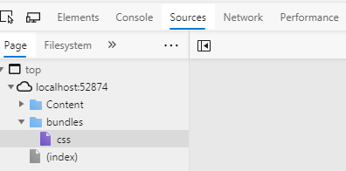

You can use the IncludeDirectory() method, version wildcard {version}, and CDN path the same way as ScriptBundle. Learn how to set image path in StyleBundle.

 Note:

ASP.NET MVC framework calls the BundleConfig.RegisterBundle() from the Application\_Start event in the Global.asax.cs file. So, all the bundles are added into the BundleCollection at the starting of an application.

# Area in ASP.NET MVC

Here, you will learn what an area in ASP.NET MVC application is and how to create it.

The large ASP.NET MVC application includes many controllers, views, and model classes. So, it can be difficult to maintain it with the default ASP.NET MVC project structure. ASP.NET MVC introduced a new feature called Area for this. Area allows us to partition the large application into smaller units where each unit contains a separate MVC folder structure, same as the default MVC folder structure. For example, a large enterprise application may have different modules like admin, finance, HR, marketing, etc. So an Area can contain a separate MVC folder structure for all these modules, as shown below.

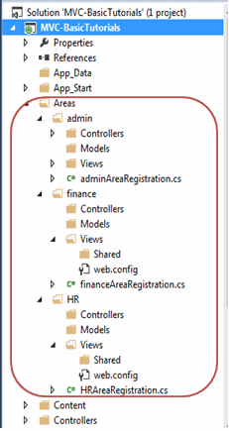 Multiple Areas in ASP.NET MVC Application

## **Creating an Area**

You can create an area by right-clicking on the project in the solution explorer -> Add -> Area.., as shown below.

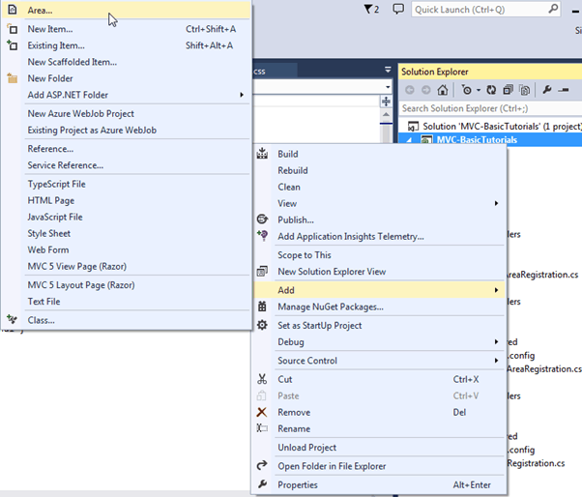

Enter the name of an area in the Add Area dialogue box and click on the Add button.

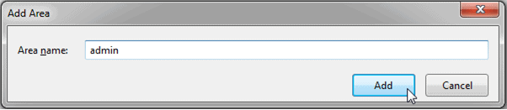

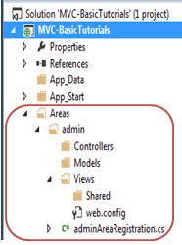This will add an admin folder under the Area folder, as shown at right.

As you can see, each area includes the AreaRegistration class. The following is adminAreaRegistration class created with admin area.

Example: Area Registration

**public class** adminAreaRegistration : AreaRegistration

{

**public override string** AreaName

{

**get**

{

**return** "admin";

}

}

**public override void** RegisterArea(AreaRegistrationContext context)

{

context.MapRoute(

"admin\_default", "admin/{controller}/{action}/{id}",

**new** { action = "Index", id = UrlParameter.Optional }

);

}

}

The AreaRegistration class overrides the RegisterArea method to map the routes for the area. In the above example, any URL that starts with the admin will be handled by the controllers included in the admin folder structure under the Area folder. For example, http://localhost/admin/profile will be handled by the profile controller included in the Areas/admin/controller/ProfileController folder.

Finally, all the areas must be registered in the Application\_Start event in Global.asax.cs as AreaRegistration.RegisterAllAreas();.

So in this way, you can create and maintain multiple areas for the large application.